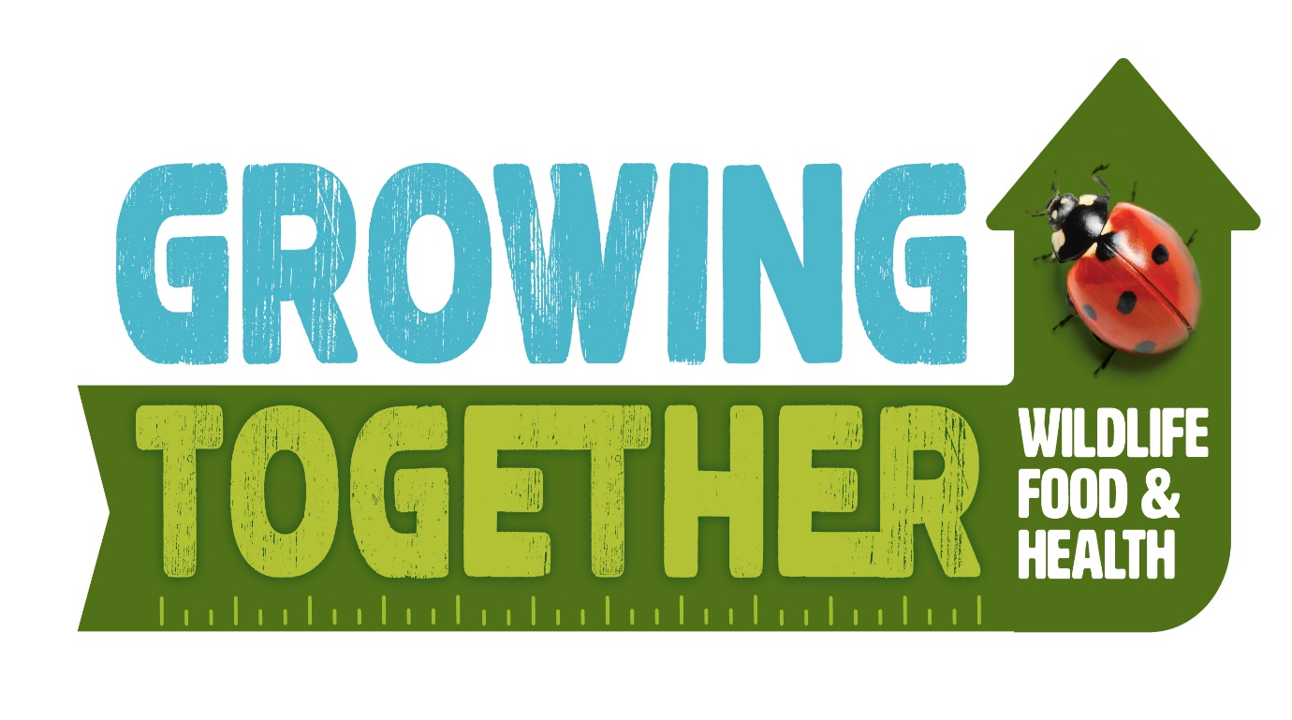

The Growing Together Project 2020
A Project designed to help children and families grow together and learn how to make changes and choices for healthier, sustainable futures. This project has been put together in collaboration with the following:
Mr John Cross
Dr George McGavin
The Thatched Tavern
Cheapside CofE School

Project Aims:
The project aims to engage and empower children and families to take action around and learn more about the role they can play in the following areas:
- Sustainable futures – pollution, air, water and land. Considering how they can live more sustainable lives – reduce, reuse and recycle. Growing own foods and harvesting home grown produce leading to greater self-sufficiency and reduced pollution.
- Using the local environment to explore the plants and animals that can be found there, learning how to support and protect these environments. Understanding the role played by different animal groups in the environment.
- Health and Well-being - what positively and negatively affects their physical, mental and emotional health. How to make informed choices (including recognising that choices can have positive, neutral and negative consequences) and to begin to understand the concept of a ‘balanced lifestyle.’ To recognise opportunities and develop the skills to make their own choices about food, understanding what might influence their choices and the benefits of eating a balanced and healthier diet.
Who will run the programme?
The Programme will be run by local experts John Cross, Dr George Mc Gavin and Mrs Ryker at Cheapside School. The children will have teaching and learning sessions with John, Dr Mc Gavin, the Year 3 teachers as well as other volunteer experts and will have some follow up tasks to do at home. Each session will be supported by teaching staff at school. Some of the sessions will be held in school, some offsite and some using The Thatched Tavern.
How long will it run?
The programme will run for 2 terms (Spring and Summer) with Nightingales Class.
How will I know what the children have learnt?
After each session, we will post an update on the ‘Growing Together’ webpage detailing what the focus of the session has been. The children will be bringing home a learning task which we would encourage you as a family to get involved with. Talk to your children, ask them questions and encourage them to tell you what they have learnt.
How can I help and become more involved?
Talk to the children about what they have learnt. Engage with the home learning tasks and think about any changes you could make as a family around sustainable futures, the environment and healthy eating. Take pictures of things you have tried to do at home and send them into school to share.
After each session, we will be giving you some suggested actions for you to do at home. Some of these actions will be our core actions. These are actions that we would like you to try and implement as a change for life. We may also offer additional suggestions linked to the session your child has had in school. We have assigned points to each suggestion, so please keep a record of any changes you make and any points you earn. We will be awarding a small prize to the child with the greatest number of points after each session! Take a look at February’s ideas below! (core actions are in green)
ACTION | POINTS
When shopping, use a reusable bag (preferably a Growing Together bag!) | 1
Every time you cook a meal together (i.e. with children helping) | 3
Every time you compost waste food | 4
Every time you sit down together for a meal (no mobiles or tablets!) | 2
As a family you help your child complete the home learning challenge and send it into school. | 4
In February:  Every time you use food in a dish flown from abroad (i.e. Kenya, Brazil etc. | -2

How can I track my points?
After each session, we will hand out a tracker sheetso you can tally the actions you have made and the points scored. Send the tracking sheet into school with your child on the day they will be having their ‘Growing Together’ session. We will count up the points and the winning family for that session will receive a small prize. A copy of February’s tracking sheet is included on the next page.

Growing Together Challenge Tracking Sheet
Child’s Name and Surname--------------------------------------------------------------
Month: February 2020
Actions taken | Tally
When shopping, use a reusable bag (preferably a Growing Together bag!)

1 points
Every time you cook a meal together (i.e. with children helping)

3 points
Every time you compost waste food

4 points
Every time you sit down together for a meal (no mobiles or tablets!)

2 points
As a family you help your child complete the home learning challenge and send it into school.

4 points
In February:
Every time you use food in a dish flown from abroad (i.e. Kenya, Brazil etc.

-2 points
Total number of points earnt for the month----------------------------------------

Other useful information
All information and handouts about the Growing Together project can be found on the school website on the ‘Growing Together 2020’ page.
www.Cheapsideschool.org.uk

