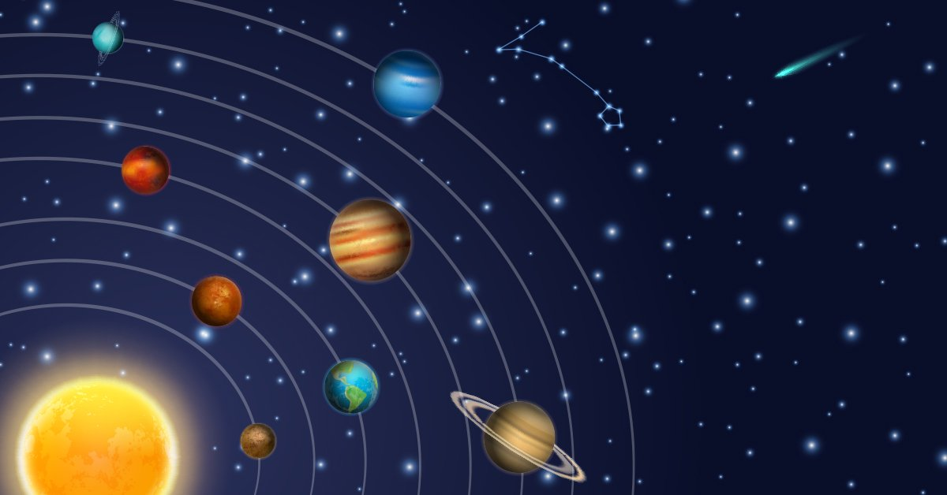
Neptune

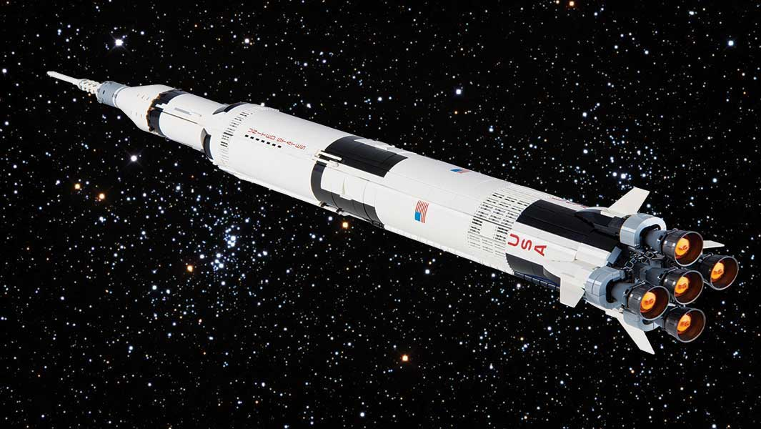
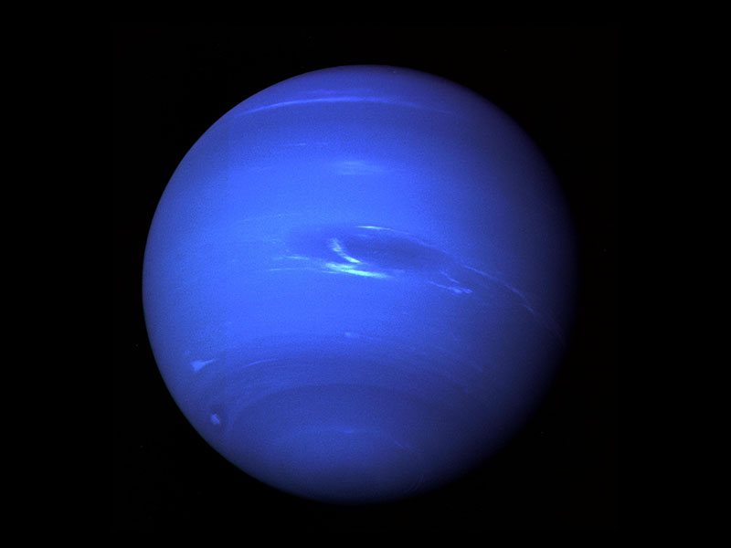

By Grace Hodgson
Contents:
PAGE
3 | Introduction
4 | Moons and Rings
5 | Size and Climate
6 | Quick Facts
7 | Word Search
8 | Grace’s Space Cake
10 | Papier Mache Neptune
12 | Bibliography
13 | Glossary
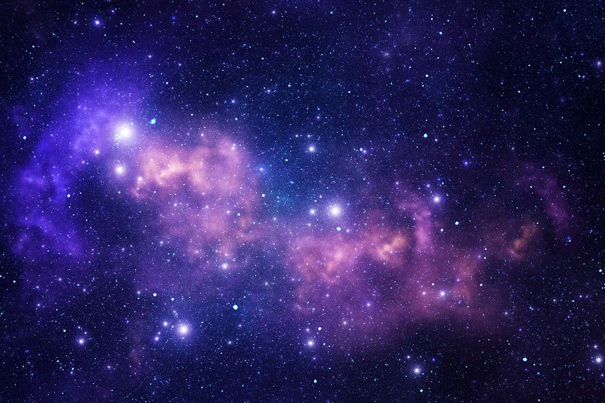

Introduction

I am particularly fond of Neptune, due to its colour. I think it stands out from the other planets. But not just for its colour but also that it is the furthest planet in our solar system.

Neptune is the eighth planet from the sun. It takes Neptune 164.8 earth years to orbit the sun. On 11th July 2011, Neptune completed its first fill orbit since it was discovered in 1846 by Jean Joseph Le Verrier.

The planet was not known to ancient civilizations because it is not visible to the naked eye. The planet was initially called Le Verrier after its discoverer.

This name, however, quickly was abandoned and the name Neptune was chosen instead. Neptune is named after the Roman God of the sea.

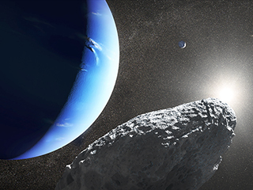

Neptune’s Moons and Rings

Neptune has 14 known moons, the biggest is Titan. Titan is frozen and spits out particles of ice and dust. It is believed that Titan was dragged towards Neptune by its very strong gravitational pull. Titan is regarded as one of the coldest worlds in our solar system.

Like the other outer planets, Neptune has a ring system. Even though the rings are faint they are probably made up of ice particles and bits of dust with a carbon-base on top. There are 6 rings to be exact.

Another fact is that it takes 16 hours to make a full rotation. This is because Neptune is not a solid body.

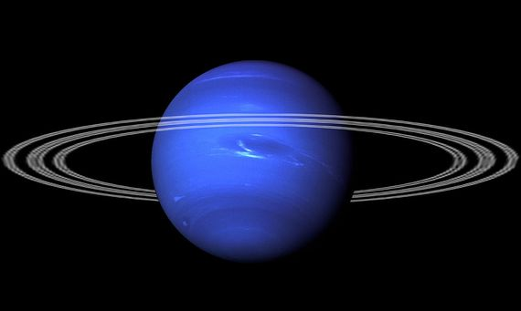

Neptune’s size and Climate
Neptune is known as an ice giant because of its cold climate although it is the smallest of the ice giants. It is dark cold and whipped by supersonic winds. The climate on Neptune is very active. Large storms sweep across the upper atmosphere. High speed solar winds circle the planet at up to 1,340km per second. Neptune’s largest storm was the great dark spot in 1989 it lasted about 5 years. How would it be if storm Denis lasted 5 years? We would still be in it not knowing what to do!
Neptune’s surface temperature is -214°C or 353°F.

The atmosphere of Neptune is made up of:
- Hydrogen
- Helium
- Methane
The methane absorbs red light which makes the planet appear blue.

Neptune is known as a gas giant as well as an ice giant, due to its composition. A gas giant is a large planet composed mostly of gases, such as hydrogen and helium, with a relatively small rocky core. The other gas giants of our solar system are Jupiter, Saturn and Uranus.

Neptune is about 4 times larger than earth with a radius of 24,622km.
Neptune is one of the biggest planets Jupiter is first then Saturn, it comes as a close third. But it has the second largest gravity in the solar system, of course Saturn is first.
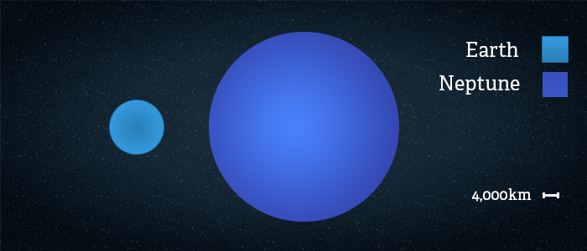
Quick Facts

- Neptune is the most distant planet from the sun
- It is the eight planet (not including dwarf planets)
- It has 6 faint rings
- Named after the roman god of sea
- A year is 165 earth years
- Spins on its axis
- Discovered by Jean Joseph
- Neptune, this is Neptune in French it looks the same but you say it in a different way

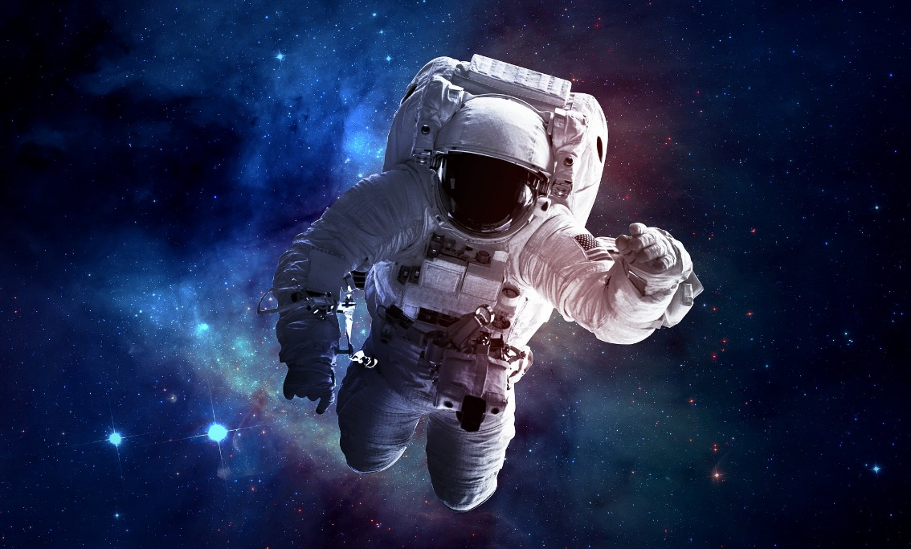
Word Search

Neptune | Planet | Solar | Spins
Jean | Joseph | Ice | Giant
Titan | Blue | Sea | Earth
Axis | Sun

N | S | Z | E | A | R | T | H
A | E | S | X | A | X | I | S
E | A | P | L | A | N | E | T
J | B | O | T | I | T | A | N
N | S | B | I | U | E | W | A
J | U | S | P | I | N | S | I
C | N | G | H | I | C | E | G
J | O | S | E | P | H | R | E
Grace’s Space Cake Recipe
Ingredients:
- 200g butter
- 200g caster sugar
- 175g self-raising flour
- 12g coco powder
- 12g drinking chocolate

Method:
First turn the oven to 180 degrees
Grease and line 2 cake tins
Put all the ingredients into a bowl
Mix until it looks right
Put the mix into the cake tins
Bake for 25 minutes
Now take the cake out
Decorate with the icing (check other recipe)

For The Icing
Ingredients:
- 125g butter
- Icing sugar
Method:
First melt the butter, for about 20 seconds
Put it in the bowl
Add icing sugar and milk until the mix has a creamy consistency
Finally add to cake and cover with space themed sprinkles
A Photo of Grace’s Space Cake

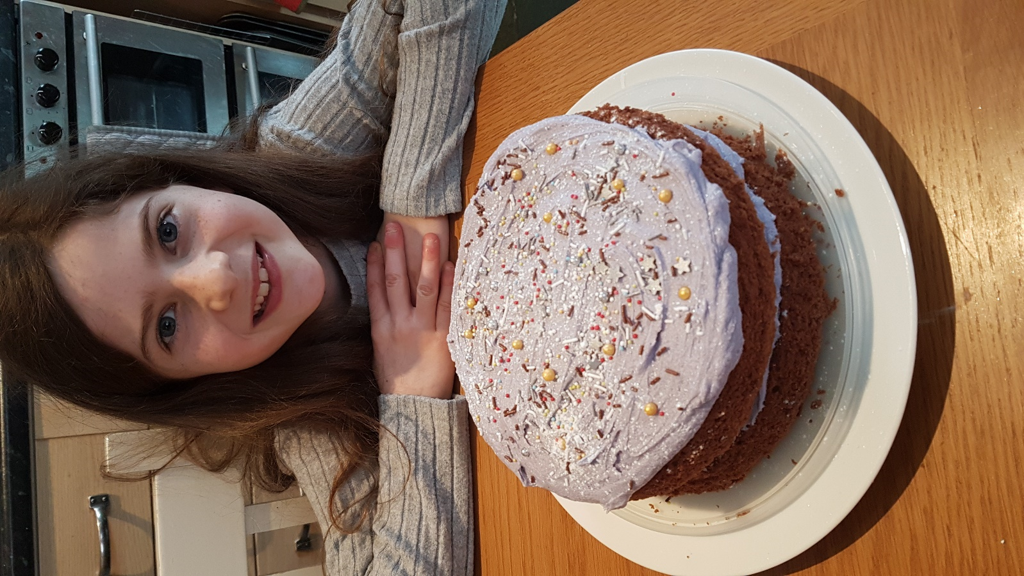

Papier Mache Neptune

- First I put pieces of newspaper dipped in glue on a balloon.
- When the balloon was dry I painted it.
- Next I let the paint dry.
- Then we made the rings using wool, paint and a laminator.

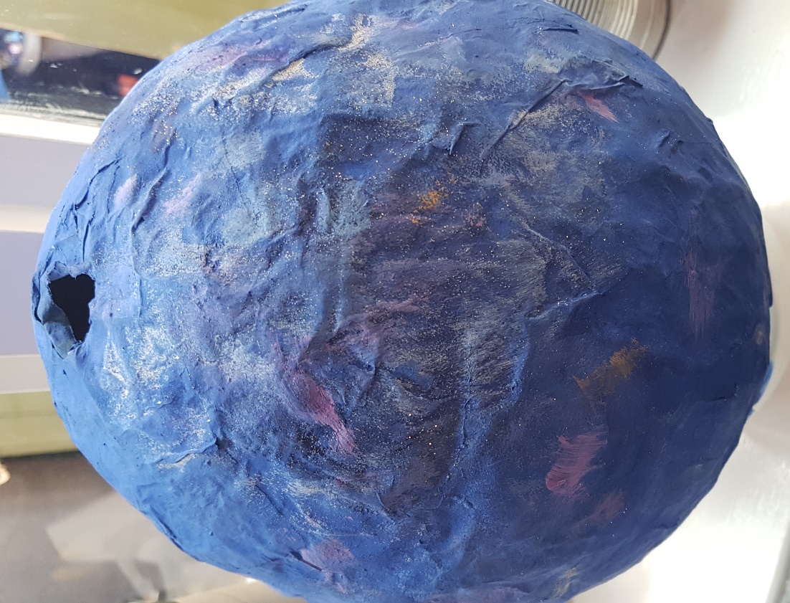
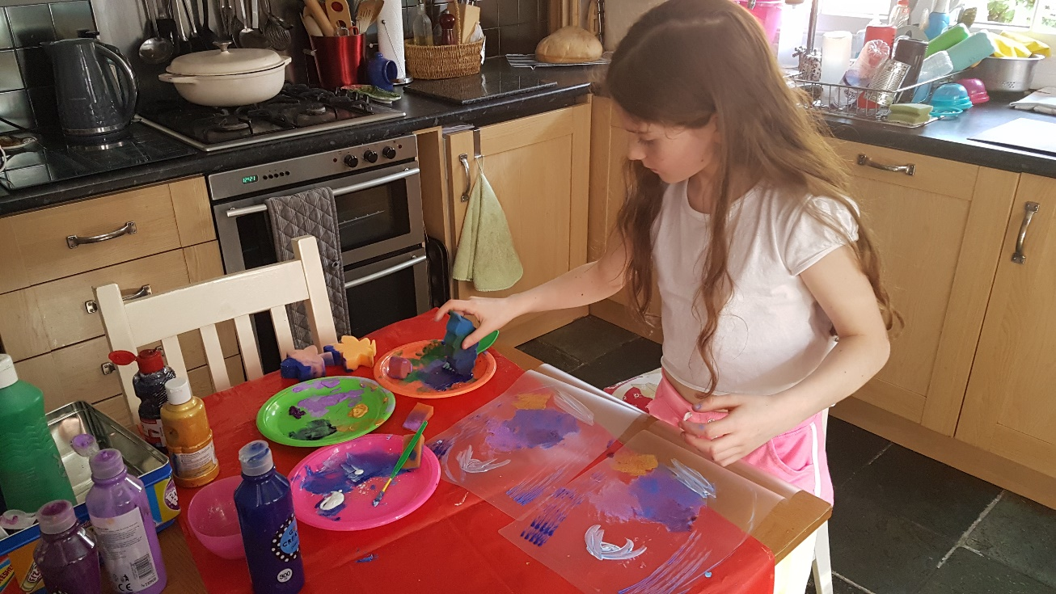

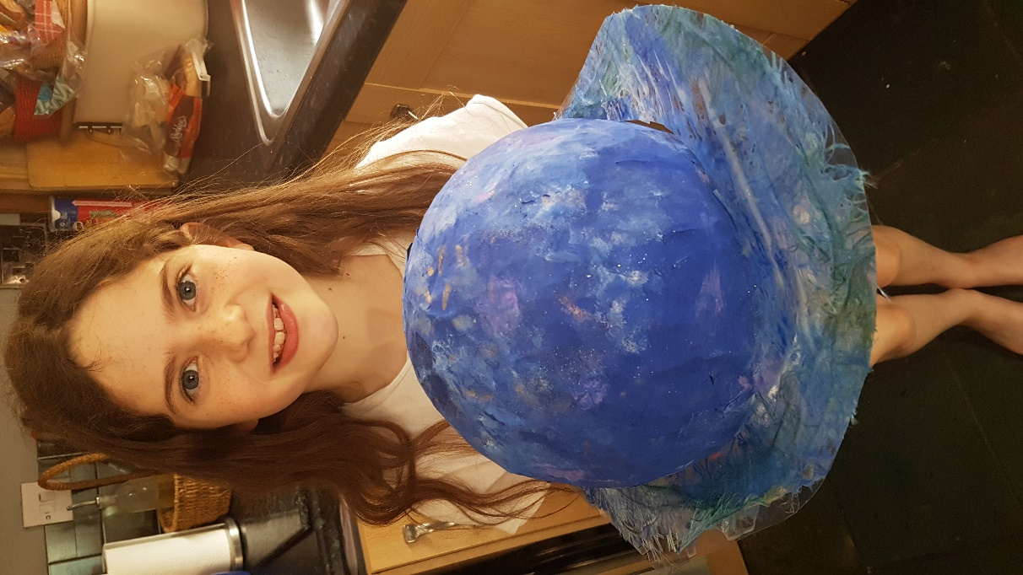
Bibliography

- https://space-facts.com
- https://theplanets.org
- https://solarsystem.nasa.gov/planets
- My Mum

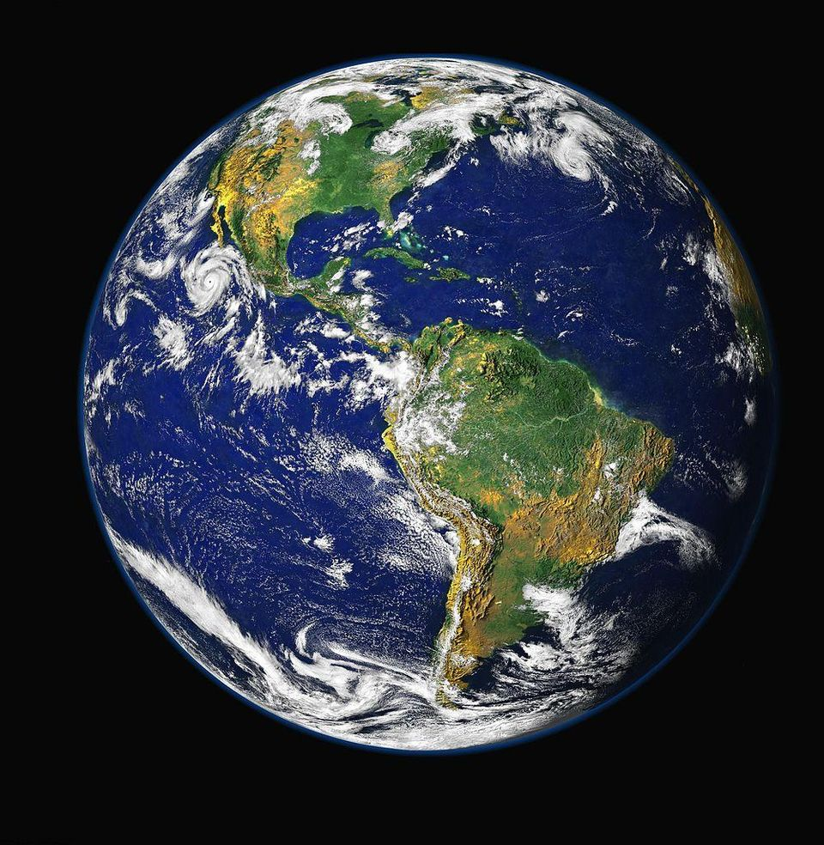
Glossary

- Ice Giant: Planets with cold atmosphere
- Gas Giant: A planet with low density. It is made from hydrogen and helium
- Axis: An imaginary line where it rotates
- Solar: Energy from the suns raise
- Dwarf planets: Things that are too small to be a planet but too big to be a meteor
- Meteor: A sort of rock that enters Earth’s atmosphere



