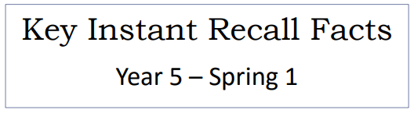


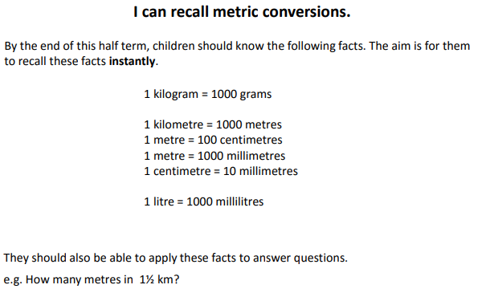
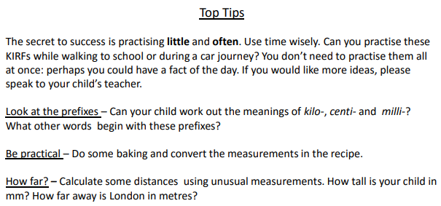

Make it Real!

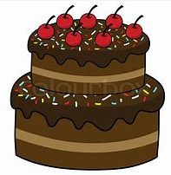
We are baking a cake and need 1 kilogram of flour. How many grams of flour do we need?
1000 grams!
How do you know?
Because kilo means a thousand so ‘kilograms’ means ‘a thousand grams’.
It is a hot day so we decide to make some lemonade. For every 4 lemons, we need to add 1000ml of soda water. How many litres are in 1000 ml?
1 litre! Are you sure? Yes because ‘milli’ means one thousand in Latin and one thousand millilitres is equal to one litre.
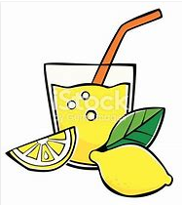

Make it Fun!
- Measure things! Use different apparatus (the wackier the better) to measure different things – your height, the size of a dinner plate in millimetres, the distance to Paris in metres etc.

- Baking/ recipes- activities are fantastic for helping children get used to the different units of measure. Can you ask them to convert between grams and kilograms? Or litres and millilitres?

