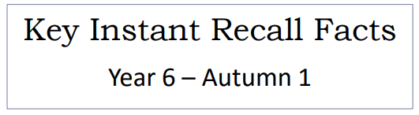


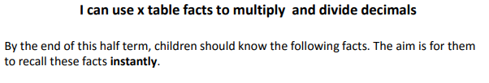

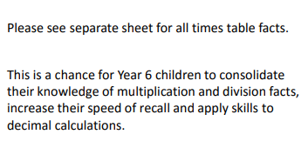
Key Vocabulary
What is 1.2 multiplied by 6?
What is 7 times 0.8?
What is the product of 3 and 0.4?
What is 8.4 divided by 7?
What is the quotient of 6.4 and 8?

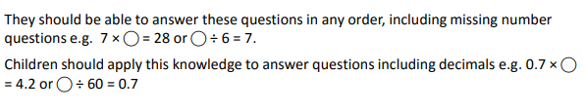

Top Tips
- The secret to success is practising little and often. Use time wisely. Can you practise these KIRFs while walking to school or during a car journey? You don’t need to practise them all at once: perhaps you could have a fact of the day. Create regular, short opportunities for rapid-fire questions where an instant correct answer is required.
- Use objects to consider the x tables in a practical way.
- Look at the patterns with both objects and numbers e.g. 5 x 7 = 35 and 5 x 0.7 = 3.5. What do you notice?
- Practise with the numbers both in order and chosen randomly- remember the aim is to be able to answer immediately.
- Chanting tables really does help- remember to practise division facts aswell as often children find them more challenging to recall.
- Online games – there are many games online which help children practise their multiplication and division facts. Use Times tables Rockstars and www.conkermaths.org.
- Memory tricks – for those hard – to – remember facts, www.multiplication.com has some unusual picture stories to help children remember.

Make it real!
A piece of ribbon is 8.4 cm in length and is going to be shared equally between 7 people. How long is the piece of ribbon that each person will receive?

1.2 cm.
Are you sure?
Yes, because 1.2 x 7 is 8.4 (and 12 x 7 is 84)

One smartie weighs 0.6 grams. In one pack, there are 12 smarties. How much would a pack of smarties cost?

7.2 grams.
Are you sure?
Yes, because 7.2 divided by 12 is 0.6 (and 72 divided by 12 is 6)
Make it fun!
Encourage children to use doubling to work out their 8x table if they already know their 4x table. If you know your 8xtable then the 0.8xtable follows the same pattern.
Playing cards
- Speed Challenge – take two packs of playing cards and remove the kings. Turn over two cards and ask your child to multiply the numbers together (Ace = 1, Jack = 11 and Queen = 12). How many questions can they answer correctly in 2 minutes? Practise regularly and see if they can beat their high score.
- Remove picture cards from the pack. Pick a card and treat the number as tenths. State the multiplication and division fact that the child is working on. E.g. pick the ‘8’ card so 7 x0.8 = 5.6 and 5.6 divided by 7 is 0.8.
Dominoes
- Pick a domino and treat this number as tenths. State the multiplication and division fact that the child is working on. E.g. the number on the domino is ‘4’ so 6 x 0.4 is 2.4 and 2.4 divided by 6 is 0.4

