Make and Design a Moving Part Monster.
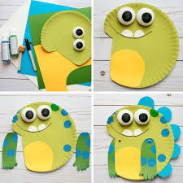
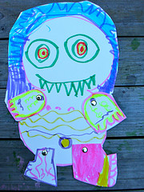

You will need: card, scissors, split pins and crayons/ felt-tips/ colouring pencils/ paint/ chalk etc.
- Draw with the pens/pencils onto a piece of card. Children can use their imagination to make whatever style monster they choose. Think about the characters in the book; do they have fur, beaks, big ears etc.
- Cut out the monster. Cut the arms and legs separate from the body (these will be attached with pins later so they can move).
- Make holes on the body and arms where they need to attach (i.e one hole on each limb, and four holes on the body). Scissors work best for this.
- Attach the limbs to the body with split pins and your monsters and done!

Or fold paper to make wobbly, logs, tongue, horns, etc.
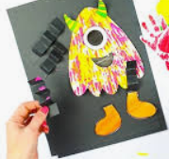
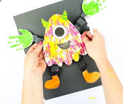

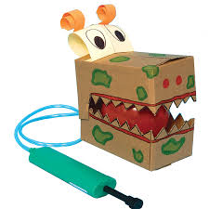
Or an air powered moving monster!

See what you can find at home. This model uses a balloon, pump, pipe and a box. You could also use paper and a straw. See what you can design!

