How quick can you grow a forest?
L.O.: Observe and describe how seeds grow into mature plants and explore the requirements of plants for life and growth
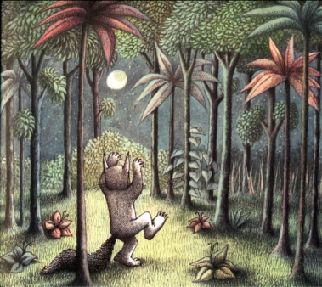
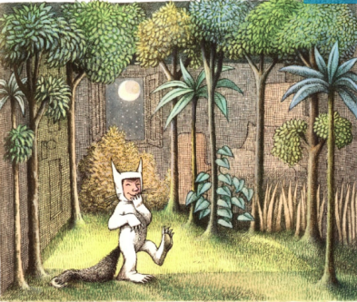
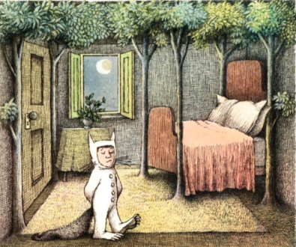
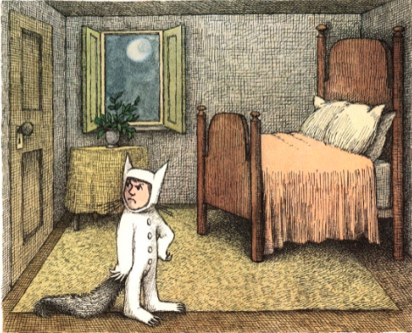
Look at the pictures of the change that Max’s bedroom went through. It happened really quickly. Could you grow a jungle in your room and, if so, how long would it take?
Not only has Max has managed to grow his jungle very quickly, but he has managed to do it without any of things plants usually need to grow: sunlight and water! But can we grow seeds without sunlight? How about without water – or even too much?
Experiment 1: Do seeds need water to grow?
Materials: seeds (cress usually grows quite quickly), 3 cotton wool pads, 3 dishes, water.
Method: In each dish, place a cotton wool with a sprinkling of seeds. Wet one with a little water. Wet one with a lot of water. Keep the other cotton wool pad dry. Watch the results!
Experiment 2: Do seeds need sunlight to grow?
Materials: seeds (cress usually grows quite quickly), 3 cotton wool pads, 3 dishes, water.
Method: In each dish, place a cotton wool with a sprinkling of seeds. Wet each with a little water. Place one in a dark cupboard; one on a table in room; and one on windowsill where it will get lots of sunlight. Watch the results!

