Grow you own grass head Wild Thing?
L.O.: Observe and describe how seeds grow into mature plants and explore the requirements of plants for life and growth
Some of the Wild Things are covered in hair, just like us.
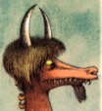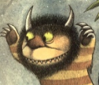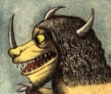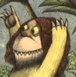
Here’s how to grow your own Wild Thing Grass Head.
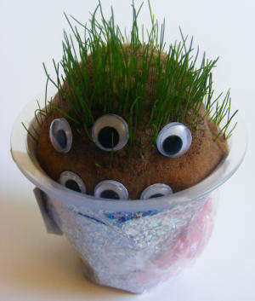
You will need:
- A nylon sock or a foot from tights or a stocking.
- Grass seed
- Sawdust
- Elastic band
- Old yogurt pot
- Googly eyes
- Paper, buttons, ribbon etc to decorate
Instructions:
- Fill the toe of your sock with grass seed. Top up with sawdust until you have a ball shape. Fasten tightly with the elastic band.

- Decorate the yogurt pot as the body using, paper, ribbon, and whatever else you can find in your craft box!

- Stand the stocking ball in the pot with the grass seed at the top. Add some eyes and any other decorative bits you like.

- Keep the yogurt pot topped up with water. After a few days your head should start to grow hair!

