HISTORY IDEAS:

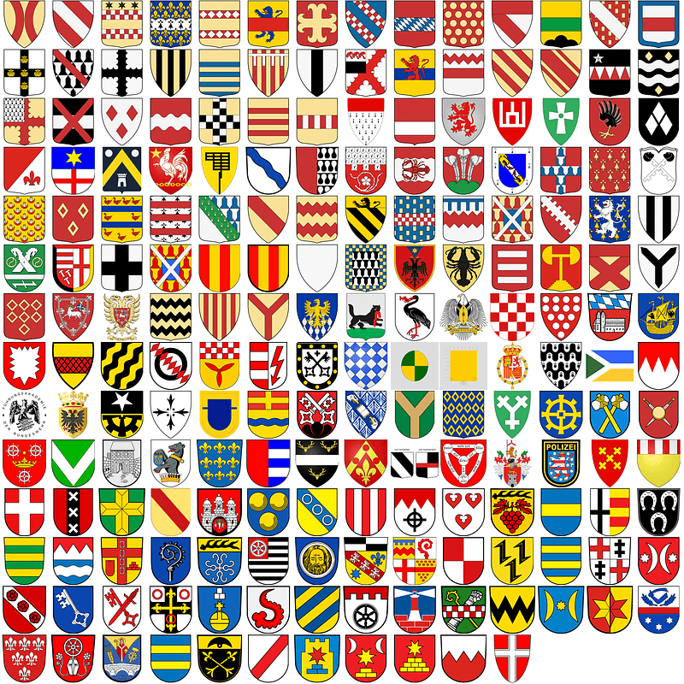
See above for some different Coats of Arms:

Activity 1.Have a go at creating one for yourself or your family
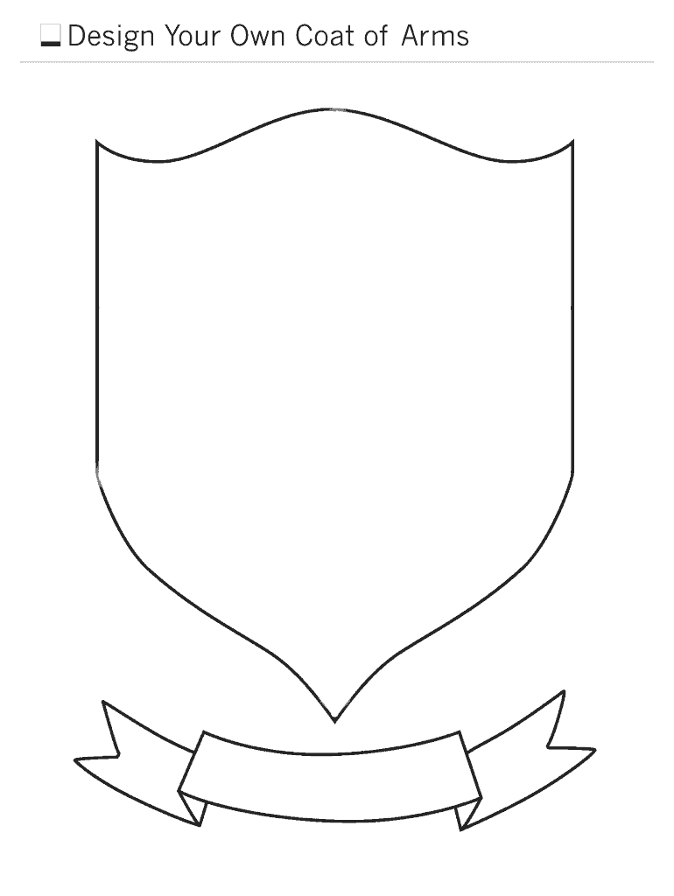

Activity 2. Toys from the Past – Short Interactive game

http://www.windowsonwarwickshire.org.uk/spotlights/toysandgames/worldtoys.htm

Activity 3. Making a Victorian cup and ball toy
. 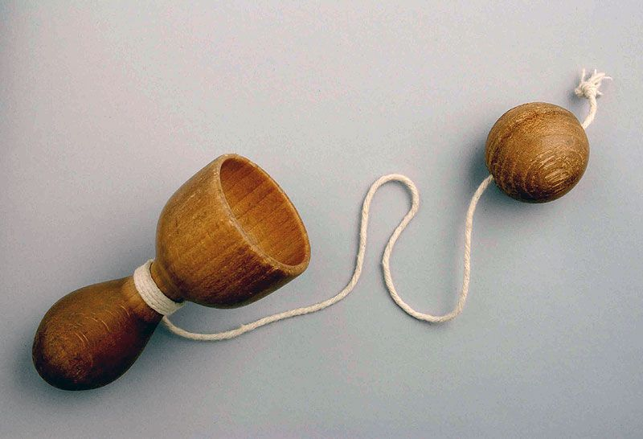

The Cup and Ball was very popular in France during the 16th Century. It was known as a 'Bilboquet'. It developed into a craze during the reign of Queen Elizabeth 1 when it became known as a Cup and Ball. Apparently even the Queen herself enjoyed playing with this toy as did all her courtiers! The Cup and Ball was played all over the world. Eskimos played Cup and Ball in the middle of the freezing snow because they saw it as a rite to hasten the return of the sun.
Suggested activity: Make a cup and ball
You will need:
- An empty yoghurt pot
- A piece of string (about 70cms long)
- A piece of silver foil
Tie a knot at the end of the string. Make a small hole in the bottom of the yoghurt pot. Thread the string through the hole from the inside of the yoghurt pot. Place the other end of the string onto the silver foil. Scrunch the foil into a ball. Now swing the silver ball and catch it in the cup!!

Activity 4: Some Victorian toy ideas to try at home –click on the link below

https://downloads.bbc.co.uk/history/handsonhistory/victorians_games.pdf

Activity 5: A fun activity all about Miniature books.-click on the link below to read all about tiny, miniature books and have a go at making one on absolutely anything!
https://www.bl.uk/childrens-books/activities/make-a-miniature-book

