ART IDEAS TO TRY AT HOME USING A RANGE OF MATERIALS THAT YOU MIGHT HAVE – ALWAYS ASK PERMISSION!
1.Collage project
https://www.bbc.co.uk/teach/class-clips-video/art-and-design-using-textured-materials-landscape-collage/zfrfbdm

2. DIY Marbled paper

MATERIALS
- Shaving FOAM
- Shallow baking dish, such as a pie plate
- Liquid water colour paint (or watered-down food colouring)
- Droppers
- Stir stick, such as a chopstick or the bottom of a paint brush
- Card (PAPER WOULD WORK TOO)
- A scraper, such as a square piece of cardboard
METHOD
First, spray a layer of shaving cream to cover the bottom of your dish.
Then, use a dropper to add drops of liquid water colour paint on top of the shaving cream.

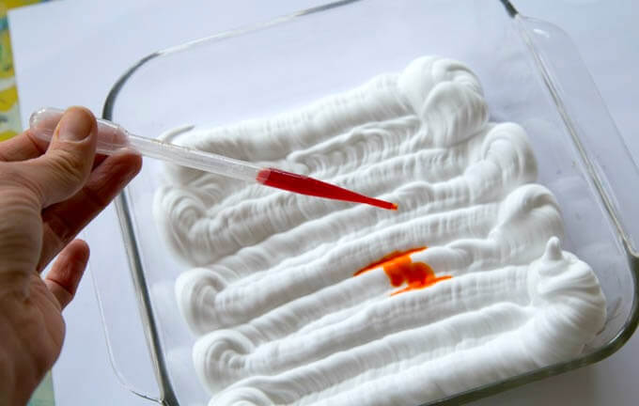

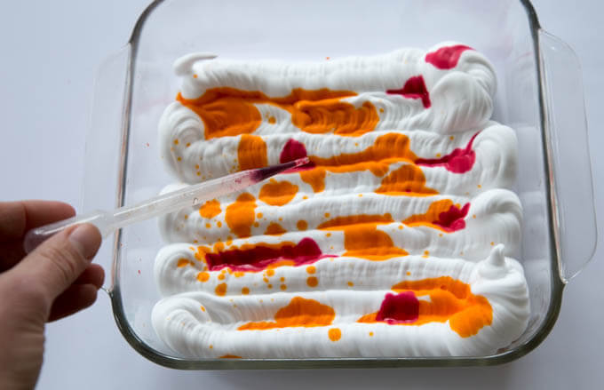
Note :: If you don’t have liquid water colours, you can use watered-down food colouring. You can even do this project with other paints, such as tempera or liquid/craft acrylics, although the results will look a bit different.
Next, use a stick (a chopstick, the end of a paint brush, or even the dropper) to swirl the paint around for a marbled effect.

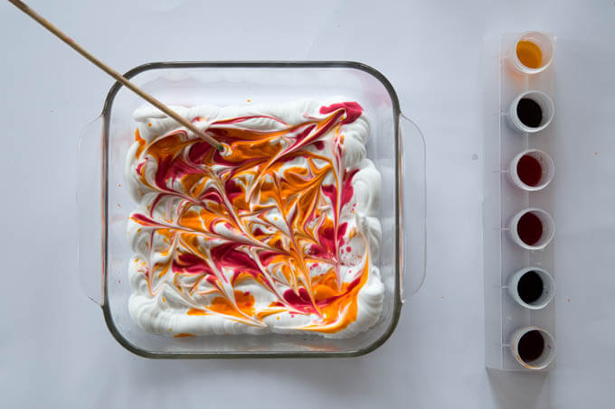

Press a piece of card stock into the paint covered shaving cream.
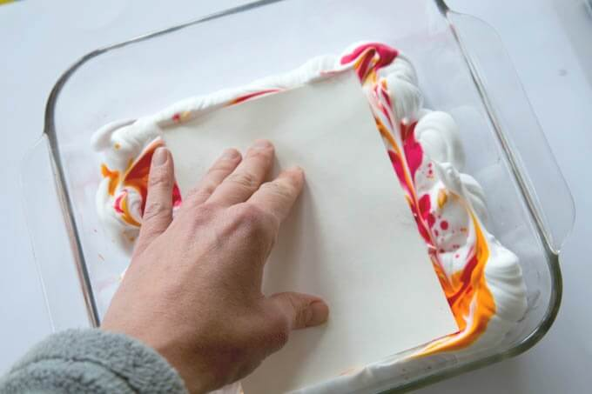
Lift up the card stock…then use a piece of cardboard to scrape off the shaving cream
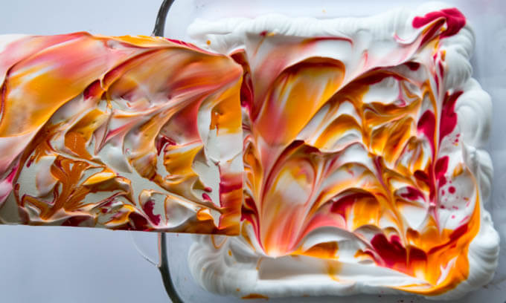
This reveals your beautiful new marbled paper! 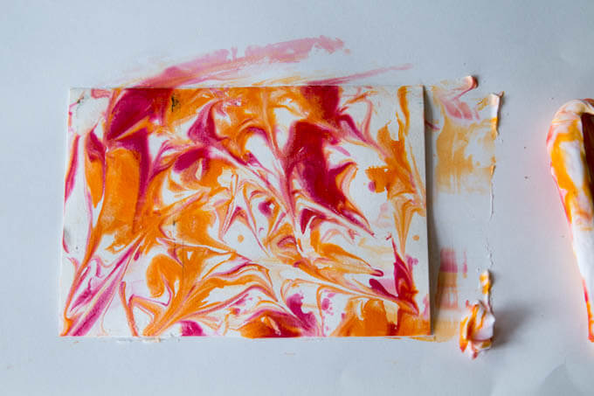

Note :: We like to keep a bowl in the centre of the table while we’re working. The shaving cream we scrape off of the newly marbled paper, gets re-scraped into the bowl. And later, when we’re finished with the activity, we use a rubber spatula to scrape the paint-y shaving cream into the trash before 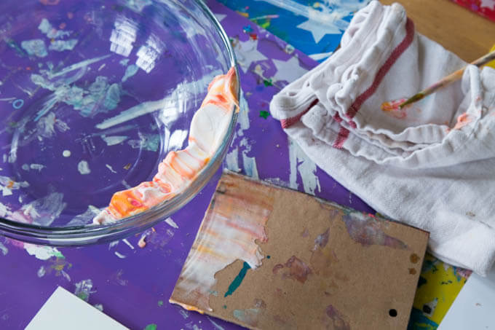
Washing up!!
You’ll get a couple of good marbled papers from the paint, but if you want more then add more drops of liquid water colour……and swirl it around……to make another piece.
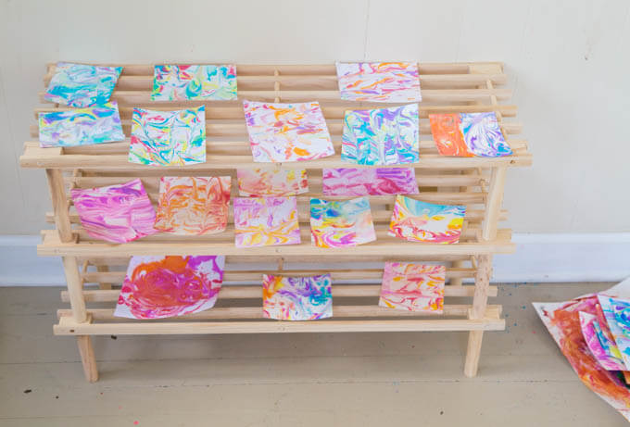

3: Sculptures

Materials: Grapes/marshmallows/gummy sweets and toothpicks

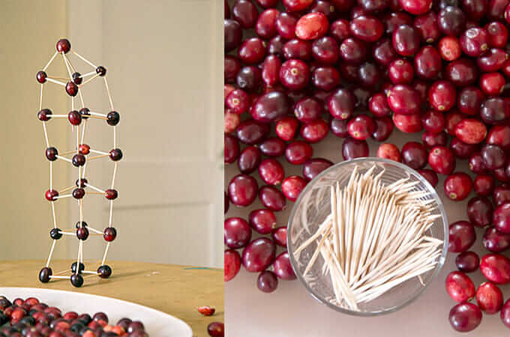
You simply set out toothpicks and a bowl of grapes/marshmallows/gummy sweets and let the children build….

Some Ideas to Try with Your Chosen food and Toothpick Sculptures

1. Tower 2. Ladder 3. House 4. Dome 5. Fence 6.Christmas Tree 7. Star 8. Wreath 9. Castle 10. Playground structures 11. Animals .

4. Garden Art
Materials: Absolutely anything !
Try and make a ‘picture’ of yourself or a family member using flowers, leaves, sticks , stones etc in your garden – here is an example

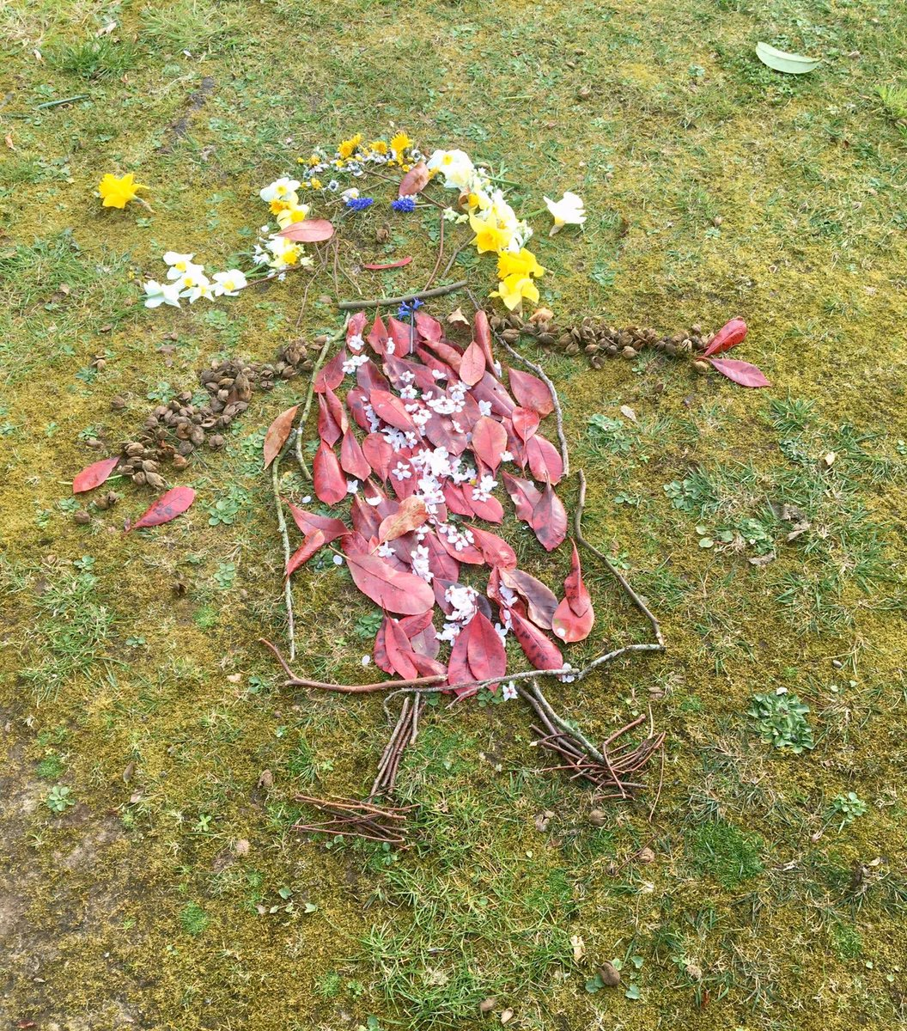

Take a photo , if possible, and email it to me at: Doveclass@cheapsideschool.org.uk and I’ll post onto the website.

5. Raised Salt Painting
MATERIALS
- Card
- Squeeze bottle of glue (such as PVA)
- Table salt
- Paints
- Paint brushes or droppers
*Any sturdy art surface will do. We’ve done this with card, poster board, cardboard, water colour paper, and paper plates. Liquid water colours are great for this activity. If you don’t have any, you can make your own by watering down food colouring.
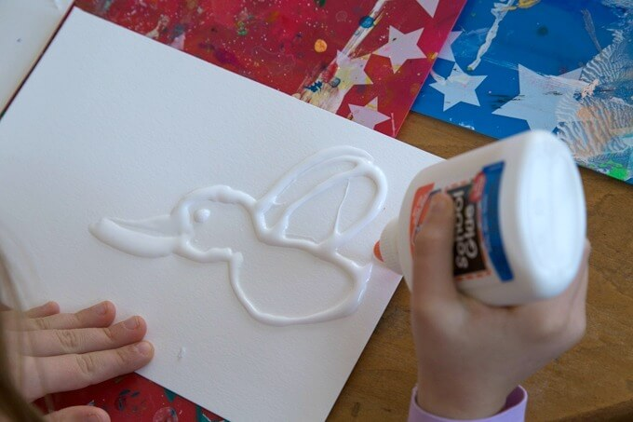
.

How to Do Raised Salt Painting
1.) Squeeze glue designs or pictures onto your card or whatever you are using
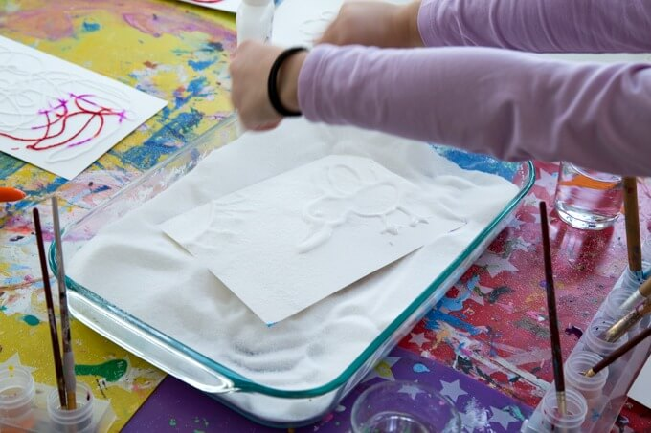
A baking dish or tray helps to contain the salt.
2.) Sprinkle with salt until the glue is thoroughly covered. Tip to let excess salt fall away.
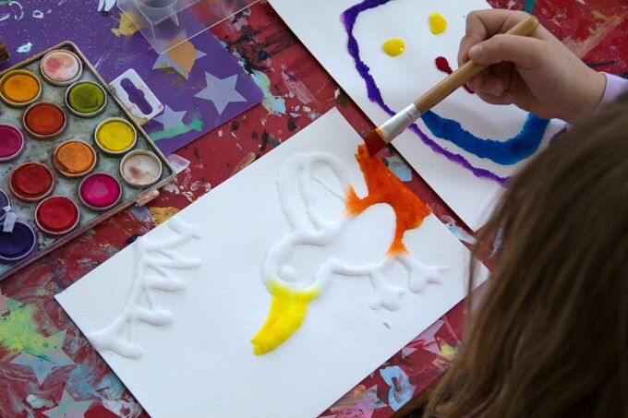

3.) Dip your paint brush into whatever paint you are using, then gently touch to the salt-covered glue lines. Watch the paint “magically” travel in both directions!
If you like, you can use a dropper or pipette instead of a paint brush to add your paint. We find that this can add a bit too much paint at a time, but I know that many people like this method.
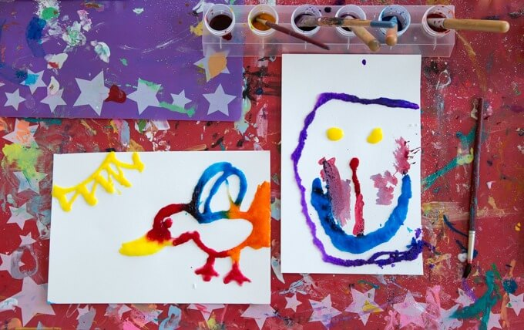
4.) Let dry thoroughly. This may take a day or two.

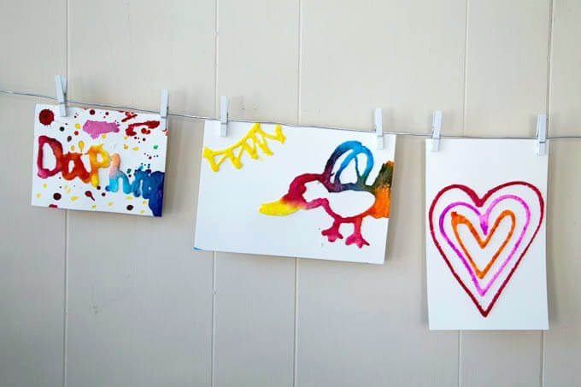
5.Enjoy!

