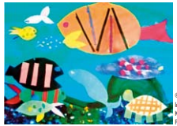
Home Learning Challenge – Underwater Poster Collage

Our Oceans resource matter – think sustainable fish!

This month we would like you to design an underwater collage. It’s a great way to recycle old magazines, packaging and pieces of fabric. This activity will help to develop imagination and creativity!
One end of the collage should depict an area of the ocean that has been overfished and polluted by humans, while the other shows a healthy sea that has flourished due to sustainable fishing practices. Try to use appropriate colours and textures to highlight the differences between the overfished and the healthy ocean. You can make your collage any size you like but should be at least A4 in size. Please include a message somewhere on your collage, that you would like to share with others about the importance of sustainable fishing.
The winning posters will be displayed in The Thatched Tavern.
The Marine Stewardship Council https://fishandkids.msc.org/en has a great website if you wanted to find out some more information about sustainable fishing to share with your family.
Please bring these into school by Thursday 28th November 2019

