


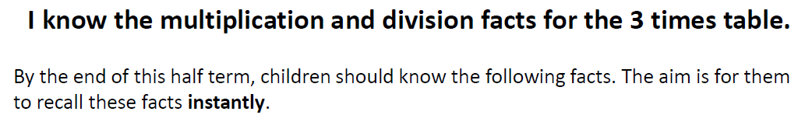

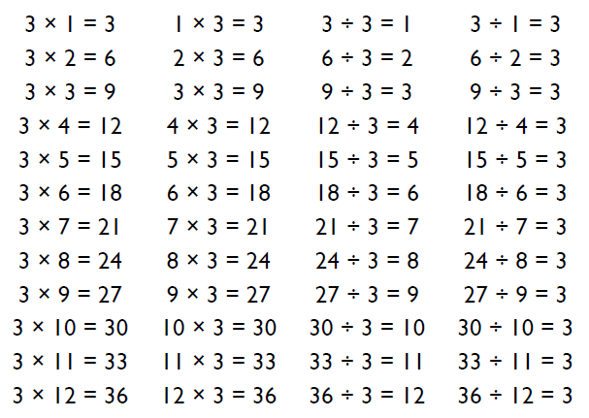
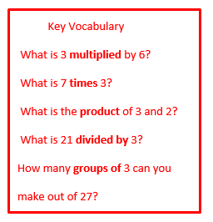

Top Tips
The secret to success is practising little and often. Use time wisely. Can you practise these KIRFs while walking to school or during a car journey? You do not need to practise them all at once: perhaps you could have a fact family of the day.
Buy one get three free - If your child knows one fact (e.g. 3 x 5 = 15) can they tell you the other three facts in the same fact family?
Warning! When creating fact families, children sometimes get confused by the order of the numbers in the division number sentence. It is tempting to say that the biggest number goes first, but it is more helpful to say that the answer to the multiplication goes first, as this will help your child in later years when they study fractions, decimals and algebra.

Make It Real!

A recipe for biscuits requires three tablespoons of honey per biscuit. If I make 9 biscuits for a school fete, how many tablespoons will I need?
27 tablespoons!
Why?
The product of 3 and 9 is 27.
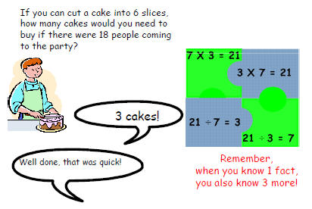

Make it fun!
Call out! Play ‘Beat the calculator’. One person works out the answer to a multiplication or division question with a calculator and the other person works it out in their head. Who is quicker?
Dice Roll a dice and generate a two-digit or three-digit number. Discuss whether the number is divisible by 3. How do you know?
Playing Cards Remove picture cards from the pack. Pick a card and state the multiplication and division fact for the three times table. E.g. pick the ‘9’ card so 9 x 3 = 27, 3 x 9 = 27, 27 ÷ 3 = 9, 27÷ 9 = 3
Dominoes To practise the 3 times table, pick a domino and add together the dots. The child multiplies the total by 3 and then give the associated division fact.
Songs and rhymes There are lots of CDs/ Apps available with musical tables. Great fun to sing along to on long car journeys!
Timed Games How well are you doing? How many questions can you answer in 2 minutes? Can you beat your own record?

