Tuesday 2nd June 2020.
In the next activity based on the story film of Caterpillar shoes, I would like you to retell the story using some star words (adjectives) to describe the different creatures and the shoes that caterpillar gives them. Please create a pictorial story map of the different creatures in the correct order as they appear in the film/story and label their features.
For example: 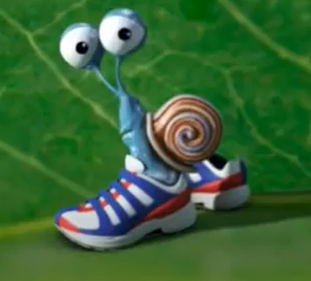 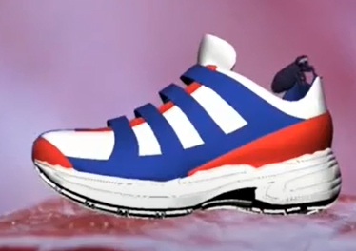
tiny snail tiny, lonely flea
spiral shell big running shoe
one slimy foot
running shoe
eyes at the end of their antennae

Use some of the words from the story and add your own.

