Monday 4th May 2020.
In addition to the daily tasks shown on the letter above for the week:-
English will be based on the traditional story of The Enormous Turnip, for which there are many versions and other books related to this.
Please read the book together if you have a copy. Alternatively use the following link:-
https://youtu.be/WfD-Oweqg-Y
Or just go straight to the version from Twinkl:-
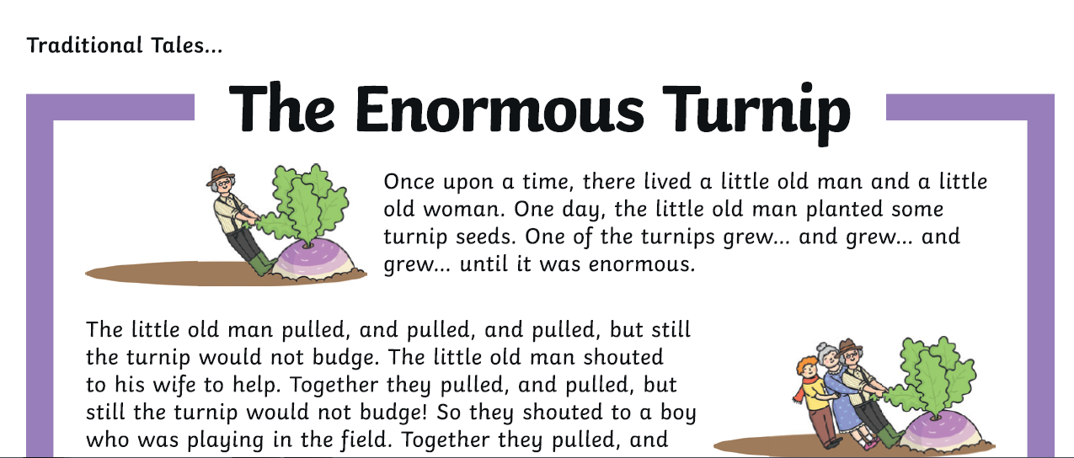
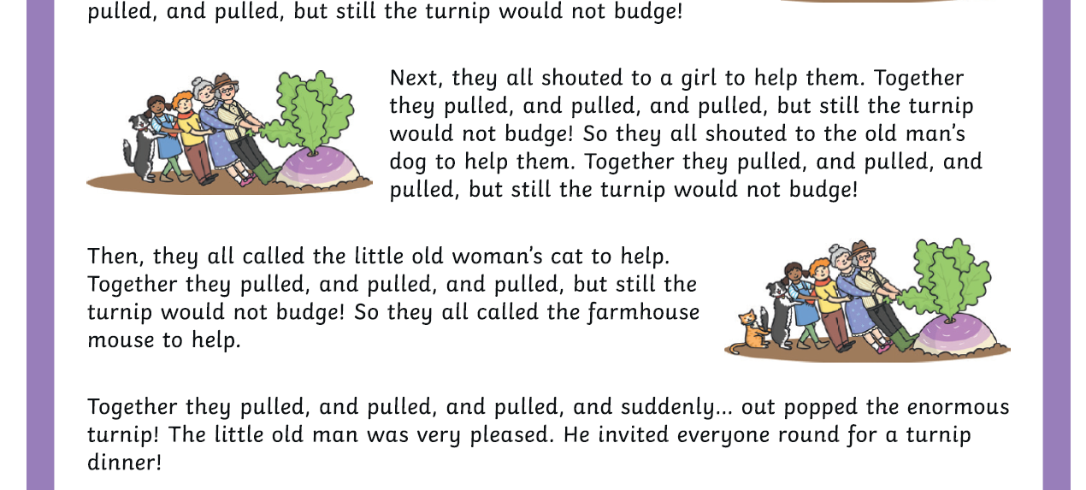
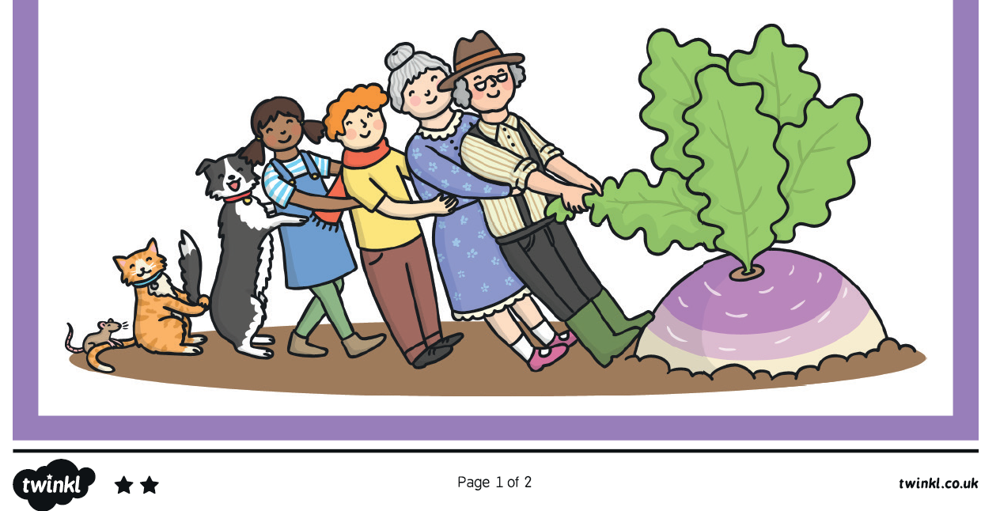
Then answer the following questions in your book, there is no need to print it out unless you prefer. Your parent/carer could act as scribe if needed:-


