Tuesday 19th May 2020.
Can you remember the rhyming words from the story I read yesterday. The chicken that hatched a cow! By Adam Bestwick. Try to match these animals to the word that rhymes:-
Magpie twin
Skunk log
Penguin how
Whale hair
Dog Deborah
Sheep slug
Bear tail
Cub sky
Zebra junk
Cow sleep
Look at the first part of the English task yesterday and write more pairs of rhyming words.
Now please listen to both parts of the story from yesterday and I would like you to think about the whole story and draw your favourite part that hopefully “put smiles on faces”. Please write why it was your favourite. It would be nice to share some of these pictures and thoughts with the author and publisher. Could you write it as a letter to Adam the author? You don’t need to put your address at the top. I can send them on your behalf.

This will also lead onto discussion about differences and how animals behave.
Chickens do not just sit on their own eggs! Last week there were three chickens in one of our nesting boxes. Later I saw just one in there and she rolled other eggs with her beak underneath her! Although only one egg hatched for this chicken,
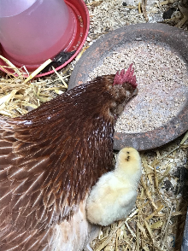 last year we had different colour chicks. Some of you might remember me bringing them into school….
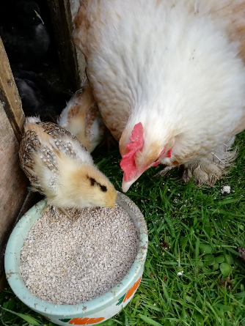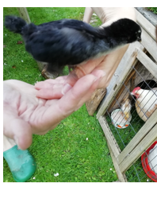
This chicken has now been sitting on eggs for a week, so we might have more chicks in two weeks time?

