Thursday 4th and Friday 5th June 2020.
So far this week we have used the story as a resource to work on fiction, but for the rest of the week, I’d like you to think about FACTS (non-fiction).
Please watch the following clip:-
https://www.bbc.co.uk/bitesize/topics/z6882hv/articles/z9fkwmn
What are minibeasts?

I would now like you to find out as many things as possible about two minibeasts of your choice. Have appeared in this clip or the story this week or be something you’ve found in your garden and would like to know more about. It should include their features, where they live (habitat), their life cycle, what they eat, their habits and use all this to produce your own fact file for each one.
Think how they are the same and different. You might like to look at the link below to develop your understanding of different life cycles.
https://www.bbc.co.uk/bitesize/topics/z6882hv/articles/zttckqt
The life cycle of animals

Then you might have information books at home, but if not there are lots of examples on the myON link from the reading zone, which you used for the Sunflower life cycle and birds.
https://readon.myon.co.uk/library/search.html

You might like to choose beetles :-
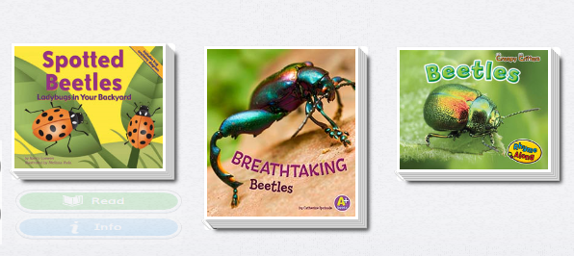

Please use these two days to find out as much as you can about the two minibeasts you have chosen.

Do they lay eggs?
Where do they live?
What materials are their homes made of?
What do they eat? Are they carnivores, herbivores or omnivores?

Write a list of new words you have learned and create your own glossary of meanings.

