Wednesday 20th and Thursday 21st May 2020.
Please start by using the following link on BBC Bitesize to find out ‘What are birds?’:-
https://www.bbc.co.uk/bitesize/topics/z6882hv/articles/zyd6hyc
Then try the quiz to check your knowledge so far. Please write your answers in your blue English book. What do you know so far? Write down everything you can think of. Then think of facts you don’t know and would like to find out.

You might have information books at home, but if not there are lots of examples on the myON link from the reading zone, which you used for the Sunflower life cycle.
https://readon.myon.co.uk/library/search.html
This time search for Birds in general or the name of a specific bird that you have an interest in. It might be based on my chicken and her chick, swans that you’ve seen or other birds.
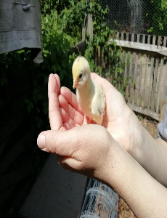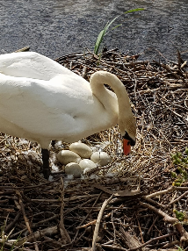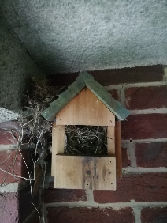
I would like you to find out as many things as possible about birds, including their features, where they live, their life cycle, what they eat, their habits and use all this to produce your own non-fiction book about birds by the end of the week. We can then share these when we come back together.

Please use these two days to find out as much as you can.
I found these egg shell in the school playground.
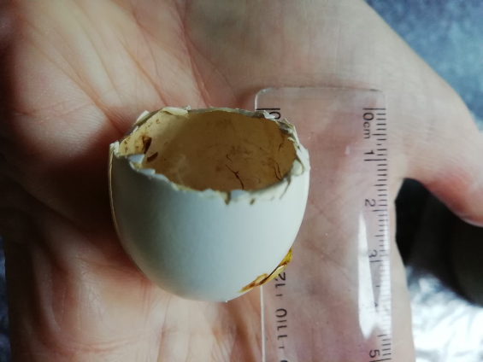 What bird do you think had been nesting in the trees and hatched chicks?
Look how it compares to one of my chicken eggs:
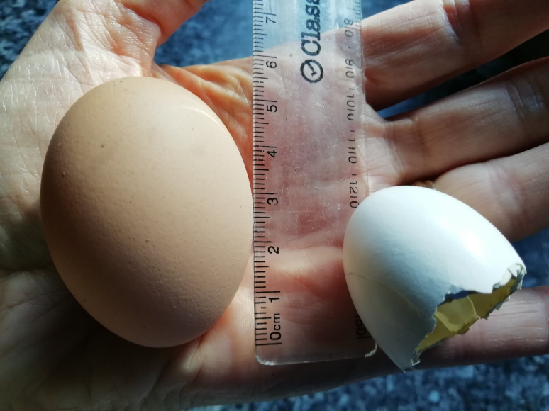 What are the biggest and smallest eggs?
How do birds create their nests? Does anyone know which bird might have made this?
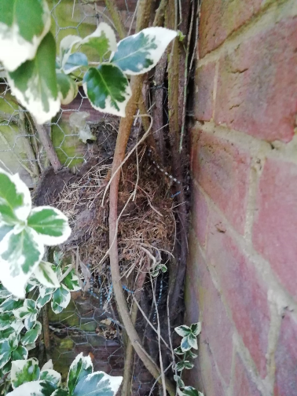 or 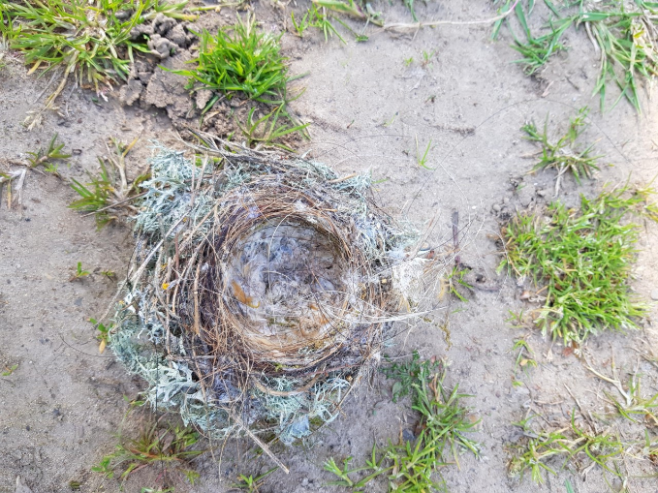
What materials do they use?
What do they eat? Are birds carnivores, herbivores or omnivores?
Please look at the links on my letter for the week. Which birds visit your garden? Which birdsongs have you heard? Take photos if possible or draw pictures. It would be great to have a variety of writing and pictures.
Write a list of new words you have learned and create your own glossary of meanings.

