Wednesday 13th May 2020.
Please use the following link:-
https://www.thenational.academy/year-1/english/instructions-to-use-the-conjunction-and-year-1-wk1-3

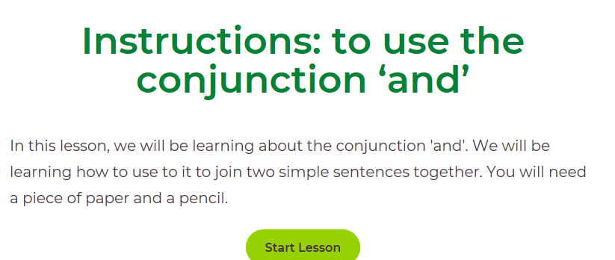
Please write all answers in your blue exercise book.

Alternatively, if you’ve used this already.
Please use the link below to go to ‘Draw a dog instruction’.
https://www.twinkl.co.uk/go/sign-in and enter unique code : SS5310.
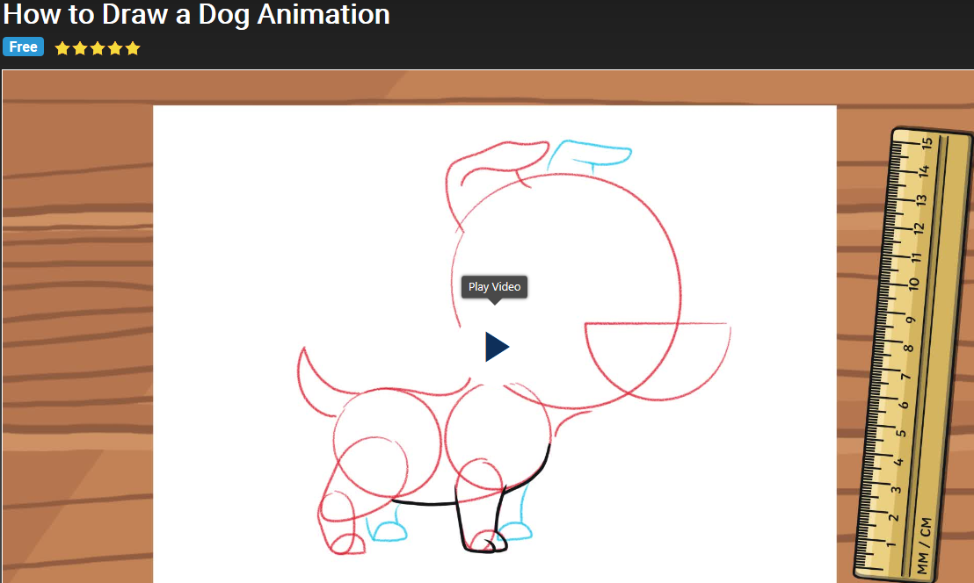

Follow the instructions and see how close you get!

