Friday 15th May 2020.
Please use the following link:-
https://www.thenational.academy/year-1/english/instructions-to-continue-to-write-a-set-of-instructions-year-1-wk1-5

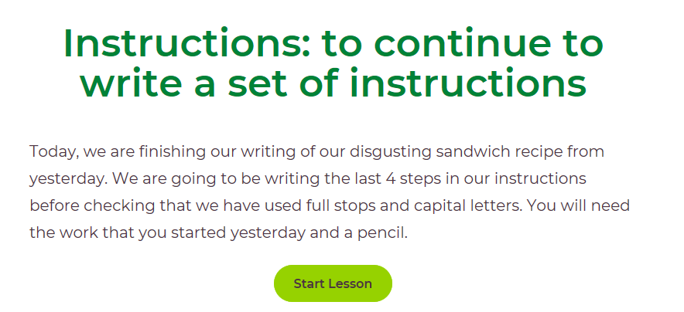
Please write all answers in your blue exercise book.
Please let me know what you and your child/ren think about this resource. Many thanks.

Alternatively, if you’ve used this already (it would be nice to see what you did for the above)… I would like you to write a set of instructions for something of your choice. It doesn’t have to be a recipe, but I know several of you have been busy baking. If so, you could use the template attached (see example below) or make your own.
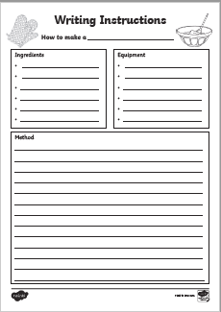
It should include a title, what you need (ingredients and equipment) and a method, for which you could use numbers or bullet points. Think carefully about the vocabulary you use and setting the instructions out clearly. You can use pictures aswell, if you wish.
You might want to write a set of instructions for planting a seed. I have now planted some sweet peas and I will keep you updated how they grow. Look how the seed compares to the sunflower seed!


