Tuesday 9th June 2020.
Please read the following poems:-
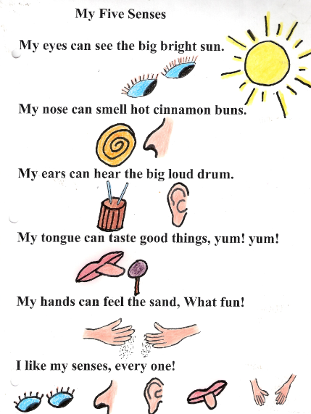
And :-
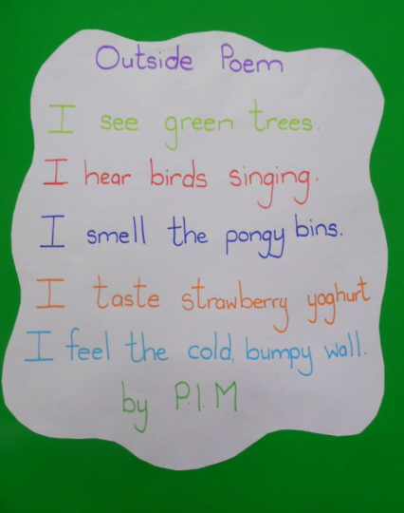 Which do you prefer and why?
Please look at this: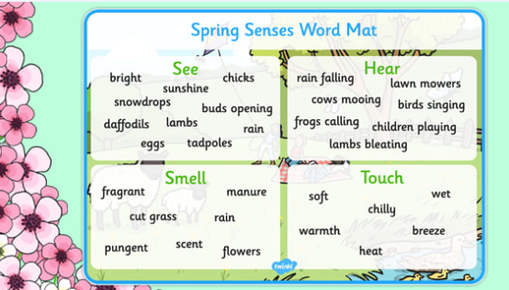 and your list from yesterday, to create your own. You can either use the template below or design your own.
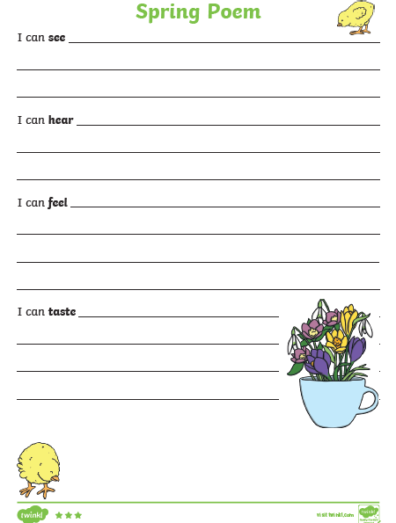
Could you include the missing sense too?

Alternative: https://www.thenational.academy/year-1/english/to-identify-rhyming-words-year-1-wk6-2

