Wednesday 3rd June 2020.
Today I’d like you to be creative and design your own pair of shoes for a minibeast! You could choose one of the creatures in this week’s story or another one not included.
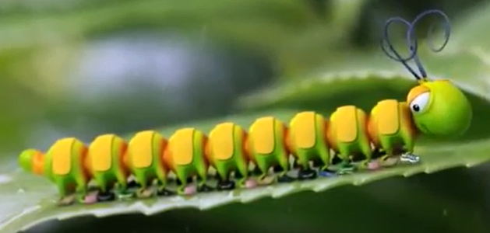
Draw and label the creature and the shoes you have in mind. Again think about using interesting star words.
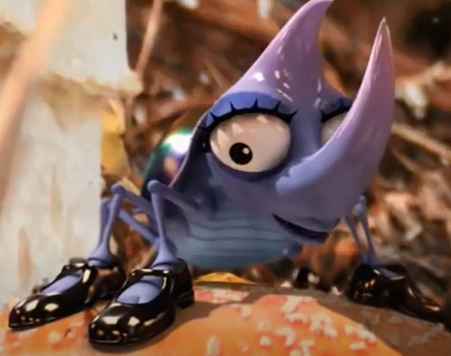 hard, shiny

