


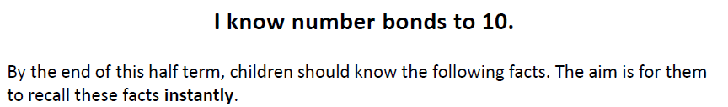

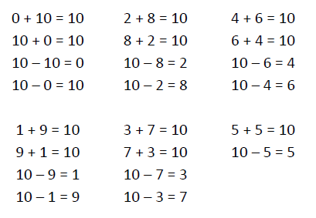
Key Vocabulary
What is 3 add 2?
What is 2 plus 2?
What is the total of 3 and 5?
How much do 7 and 1 make altogether?
What is 5 take away 2?
What is 1 less than 7?
What is the difference between 8 and 4?

Top Tips
- The secret to success is practising little and often. Use time wisely. Can you practise these KIRFs whilst walking to school or during a car journey? You don’t need to practise them all at once: perhaps you could have a fact of the say.
- Use practical resources - your child has one potato on their plate and you decide to give them two more. Can they say how many they will have altogether?
- Look at the patterns with both objects and numbers e.g. as one number increases, the other one decreases.
- Make a poster – your child could make a poster showing all of the different ways to make 10.

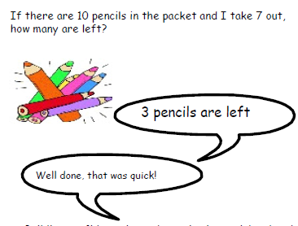
Make it Real!
If you put £1 in your moneybox on Saturday and £3 in your moneybox on Monday, how much money will be in there altogether?
£4! How do you know?
Because £1 add £3 equals £4




In the shop, you spend £2 on a pencil and notepad. If you give the shopkeeper a £5 note, how much change will you receive?
£3! Can you explain your answer? Because the difference between £5 and £2 is £3.
I subtracted 2 from 5.

Make it Fun!
Call out! Use a puppet or favourite teddy to count to 10, making a mistake. Can the child spot the mistake and explain what is wrong before counting along correctly with you.

What’s hidden? Play bunny ears! Adult to hold up 4 fingers to make ‘ears’. Child makes ears with 6 fingers (bonds to 10).
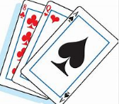
Playing cards Remove picture cards from the pack. Ace becomes 1. Hold up a card and child replies with the number needed to equal 10. Increase difficulty – adult holds up a card and shouts out a random number between 1 and 10 – what must you add to the number on the card to equal the number you have called out? E.g. Hold up a ‘3’ and adult calls ‘7’ so child responds with ‘4’.

Songs and rhymes There are lots of songs available to support number bonds e.g. 10 green bottles or 10 in a bed. Play online you can play number bond games online at www.conkermaths.com.
Timed Games How well are you doing? How many questions can you answer in 2 minutes? Can you beat your own record?

