

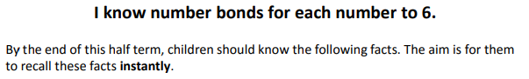

Key Vocabulary
What is 3 add 2?
What is 2 plus 2?
What is 5 take away 2?
What is 4 subtract 3?
What is 1 less than 4?

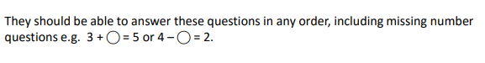
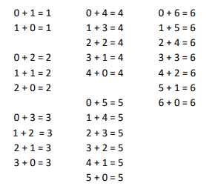

Top Tips
- The secret to success is practising little and often. Use time wisely. Can you practise these KIRFs whilst walking to school or during a car journey? You do not need to practise them all at once: perhaps you could have a fact of the day.
- Use objects to consider the bonds in a practical way. E.g. your child has one potato on their plate and you give them three more. Can they say how many they will have?
- Look at the patterns with both objects and numbers. E.g. as one number increases the other one decreases.
- Practise with the numbers in order and chosen randomly-remember the aim is for the child to be able to respond immediately.
- Play games- your child can play number bond pairs online at www.conkermaths.com and then see how many questions they can answer in just one minute.

Make it real!

There are 5 ladybirds on the leaf. Three fly away, how many are left?
2 ladybirds!
How do you know?
Well, 3 add 2 make 5.
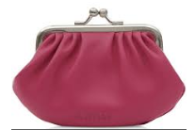
I have 4 pence in my purse. How much more do I need to make 6p?

2p! Why? Because 4 pence and 2 pence is 6 pence altogether.


Six teddies are sitting on a shelf, 1 fell off. How many are left on the shelf?
Five! Why? Because 5 plus 1 is 6 in total.

Make it fun!
Call out!
Play number ping-pong. Start by saying ‘ping’ and the child replies with ‘pong’.
Repeat and then convert to numbers i.e. say ‘2’ and they reply ‘4’ (number bonds to 6).

What’s hidden?
There are 6 beans on this place, I hide some under a cup- how many have I hidden?

Playing cards (take out the picture cards, 7, 8, 9, 10, and use joker as zero)
- Play snap by matching the number bonds.
- Play the ‘memory game’ to find matching number bonds.
Dominoes
Connect two dominoes to make the bond.

Songs and rhymes
E.g. six speckled frogs, 6 green bottles, 6 in a bed

Timed games (important that if you do this, the child understands the importance of focusing on the improvement that they are making).
How many questions can you answer in 2 minutes? Can you beat your own record?

