Wednesday 10th June 2020.
Today I’d like you to read/sing the following poems:-
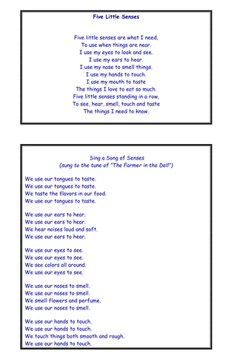
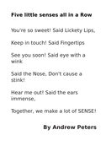
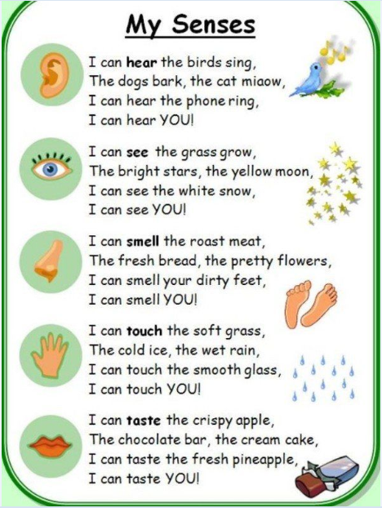Which of these do you prefer and why?
Can you find any other poems about the senses? Which is your favourite and why?

Alternative: https://www.thenational.academy/year-1/english/to-identify-onomatopoeia-year-1-wk6-3

