Friday 22nd May 2020.
Today I would like you to put together all the information you have collected over the last two days and create your own non-fiction book about birds. Think about all the features we have looked at in Guided Reading. Please design a front cover. Then write a list of Contents…what order should it be in?
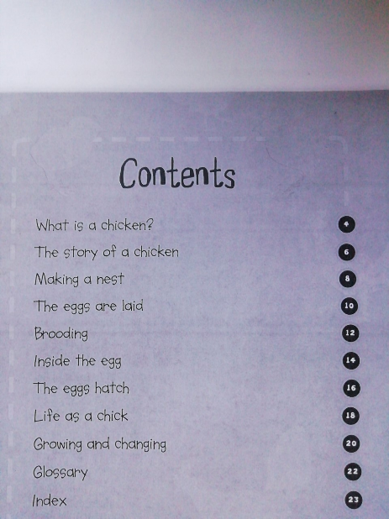 ……..page order.
Then write your Glossary and an Index. What order would this be in?
Alphabetical!
Could you have a page of most interesting facts that we could share on our class page?
I look forward to seeing what you produce and sharing them soon to find out lots of new information!

