Tuesday 12th May 2020.
Please use the following link:-

https://www.thenational.academy/year-1/english/instructions-to-commit-a-set-of-instructions-to-memory-year-1-wk1-2
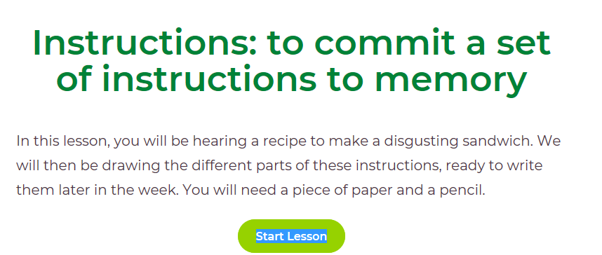
Please write all answers in your blue exercise book.

Alternatively, if you’ve used this already. Today I’d like you to think about something you do twice a day: BRUSH YOUR TEETH! Think about your method…what order do you do it. Please use the pictures attached or create your own to form a set of instructions for brushing your teeth.
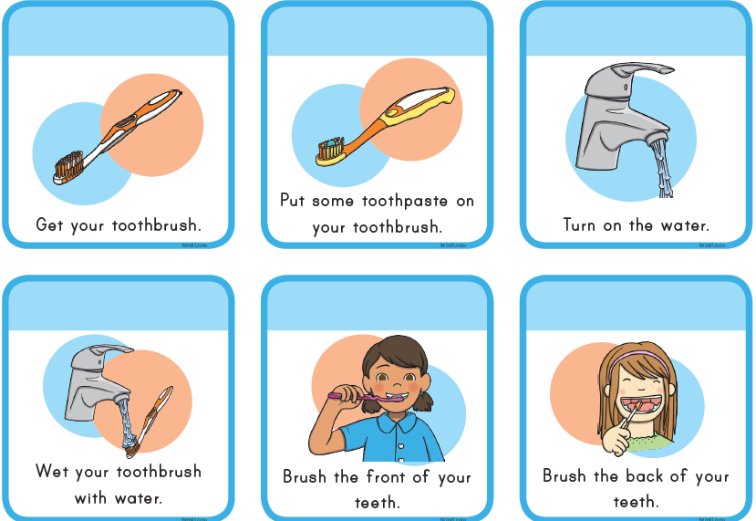
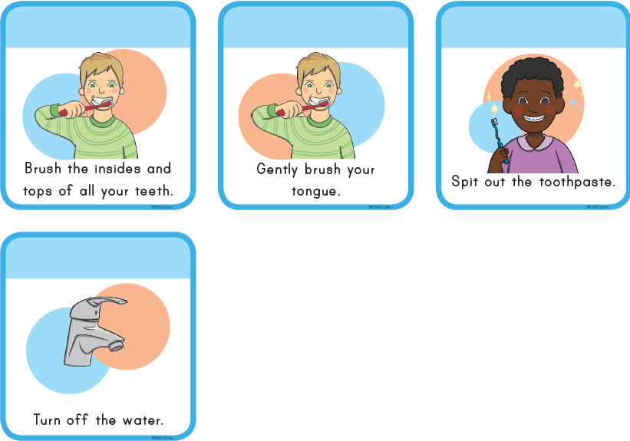
Remember that the verb usually comes first!

