1st May 2020
Dear Robins, Parents and Carers,
I hope that you have all had a good week, despite the change of weather and have continued to promote a home learning routine that suits you and your family. These are still uncertain times and I can appreciate that it is likely some parents/carers need to manage working from home as well as educating children! Please do what you can.
Thank you to those of you have responded with feedback and made contact this week. Following on from the letter you received from the SLT last week, we have made a few amendments. For example, the White Rose maths sheets will be listed daily on the class pages.
I hope you and your child/ren are enjoying the Class page. It would be great to receive everyone’s Sunflower Art to add to the gallery. Hopefully you are finding the other links on the school website useful (e.g. Reading zone and Wellbeing). We are trying to make the most of everything that is being made available!
Daily tasks include:-
Reading (school/home books). Please continue to record reading in the Record books. Hopefully your child is enjoying the new book Superdog I’m reading and perhaps you are sharing another book with your child/ren too. If you haven’t already, please refer to the Reading Zone, which can be found on the Children tab of the school website. It has many great links to try. It is being updated regularly to include many different options to suit your needs.
Phonics/spelling (back of blue exercise book):
Hopefully everyone had a chance to view the Letters and Sounds Phonics link which was issued too late to be included in my letter last week; so was shown on the class page. I would like you to use these daily lessons. Please let me know how your child/ren get on.
If you do not have access to these youtube lessons, I would like you to focus on spellings with the suffixes ing, er and ed:-
hunting, hunter, hunted, buzzing, buzzer, buzzed, jumping, jumper, jumped, walking
Then during the week, write a sentence for each word. Remember those capital letters to start and punctuation at the end.
Again, there is a related quiz on Purple Mash. I have extended the dates on all previous Purple Mash activities, so if you haven’t had chance to try these, please do if you can. Remember to ‘hand in’ before save and exit.
Remember to try and practise the common exception words given this term- at least once this week and think about your handwriting style.
As mentioned last week, it has been decided not to include handwriting sheets, but look at www.teachhandwriting.co.uk (Route D. Choice 3) if you would like to continue this. Instead we would like you to try some of the Handwriting warm up exercises on their site.

Maths KIRF: (back of green exercise book). Now we have five KIRFS which we have worked on in year 1. There may be particular areas that need to be a regular focus as a starter. Alternatively use some of the sites suggested recently or just continue working through Numbot levels.
Please remember the resources included in the pack (cubes, ruler/number line, hundred square) to aid the maths.
Hopefully you are getting used to the White Rose Maths home learning. This week you will working on the next unit titled Summer Term week 1 (w/c 20th April)
https://whiterosemaths.com/homelearning/year-1/
Please encourage your child to watch the relevant video each day and pause as appropriate before starting the tasks. As was stated in the letter dated 23rd April, it is not felt necessary to print out the worksheets or challenges; unless you would prefer to. The work can be written into the green books and then checked with the answers at the end. Following feedback I have received that White Rose is not sufficient… I am including a challenge for Monday to Thursday too, as White Rose has various challenges for Bank Holiday Friday, if you want them!

For English this week, you will be reading and writing about the traditional story The Enormous Turnip and comparing it with other versions eg. The Enormous Potato, before writing your own version.

Science will be the focus of our additional activity this week. You were all given a sunflower seed to plant and although not everyone has had success, you will have seen the growth on the class page.
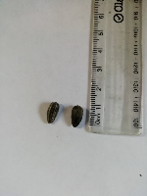 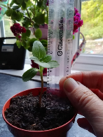 This is the beginning of the life cycle of the sunflower.
I have been growing various vegetables in my greenhouse/garden including potatoes, carrots, peas, beans, parsnips, sweetcorn and pumpkins.
We would have planted some potatoes together at school, so I have taken photos of their seed 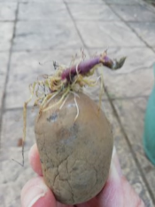 and progress so far.
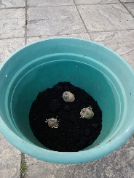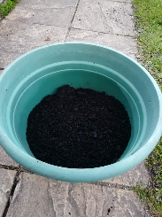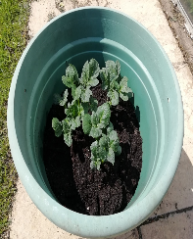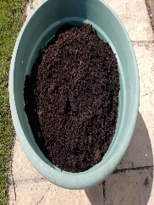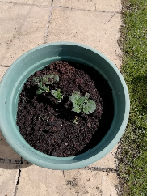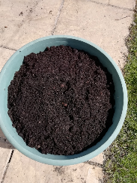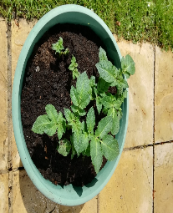
Some of you have sent me photos of gardening you have been doing. It would be great to know what you have planted and are growing.
Please go onto the myON site on the Reading zone, where you can access A Sunflower’s life cycle by Mary R. Dunn.
Then either based on the sunflower, potato or something you have been growing. I would like you to design a poster to show the life cycle of your chosen plant. Please include writing and drawings (or photos if you have them). It might look something like this:-
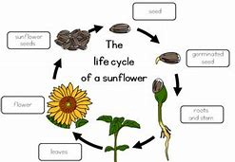
Please send me photos of your posters.

Keep looking at the school website/class page for updates and please send me examples of what you’ve done. I look forward to hearing from you.

Take care and look after yourselves at this difficult time.
Many thanks for your support,
Mrs Spong robinclass@cheapsideschool.org.uk

