29th May 2020
Dear Robins, Parents and Carers,
I hope that you have all had a good half term. It would be good to hear what you have been up to and I will continue to update the class page slideshow to share your news. Well done everyone keeping busy and trying new things. You might have taken more exercise this week; hopefully keeping safe in the heat!
Congratulations to Penny, who is the runner-up in this years Royal Ascot Schools Art Competition! Well done.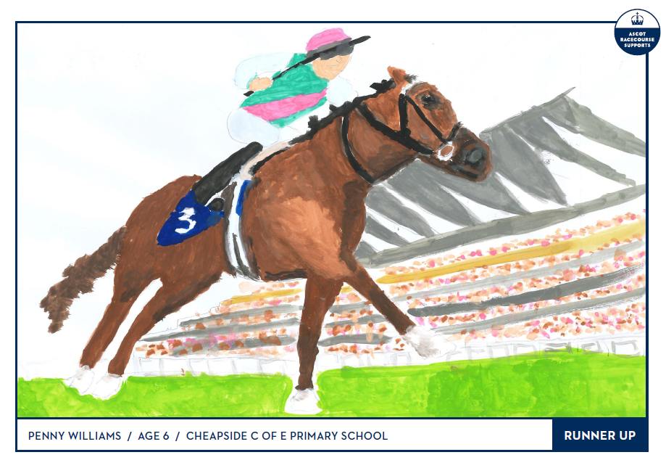
I hope you continue to find the links on the school website useful (especially the Reading zone and Wellbeing tabs on the Children page). We are trying to make the most of everything that has been made available. The Curriculum pages continue to be developed all the time.
Please continue to follow a home learning routine that suits you and your family best. Do what you can and don’t feel pressure to complete everything. This will be the last week in the current format and then as advised in the letter dated 22nd May; there will be some changes on 8th June.
Daily tasks include:-
Reading (school/home books). Please continue to record reading in the Record books. Hopefully your child /ren enjoyed the ‘Harry, rabbit on the run’ story I read before half term and it’s nice to hear about the books you are sharing with your child/ren too. I plan to start a new book on Monday. If you haven’t already, please refer to the Reading Zone, which can be found on the Children tab of the school website. It has many great links to try. It is still being updated regularly to include many different options to suit your needs.

Phonics/spelling (back of blue exercise book):
Hopefully everyone has had a chance to view the Letters and Sounds Phonics lessons. I would like you to use these daily lessons; as it is the scheme used in school, but if your child does not enjoy them or you would rather not use the screen too much, I will continue to include a set of spellings you can focus on instead.
This week will be spellings with two syllables:-
pocket, rabbit, carrot, thunder, sunset, market, office, magic, puppet, target.
Then during the week, write a sentence for each word. Remember those capital letters to start and punctuation at the end. You could add to this list or create a dictionary of words with more than two syllables.
Again, there is a related quiz on Purple Mash.
I have extended the dates on all previous Purple Mash activities, so if you haven’t had chance to try all these, please do if you can. Remember to ‘hand in’ before save and exit, unless it saves automatically.
Remember to try and practise the common exception words given this year- maybe a different set each day and think carefully about your handwriting style.
Autumn 1 | Autumn2 | Spring 1 | Spring 2 | Summer 1 | Summer 2
the | do | says | your | friend | Review of any spellings still not secure
a | was | are | they | school | Review of any spellings still not secure
to | me | were | love | put | Review of any spellings still not secure
I | be | by | come | push | Review of any spellings still not secure
is | he | my | some | pull | Review of any spellings still not secure
of | said | here | one | full | Review of any spellings still not secure
you | she | there | once | house | Review of any spellings still not secure
go | we | has | ask | our | Review of any spellings still not secure
no | so | today | where | his | Review of any spellings still not secure
BBC Bitesize has some useful guides too.
As mentioned previously, it has been decided not to include handwriting sheets, but look at www.teachhandwriting.co.uk (Route D. Choice 3) if you would like to continue this. Instead we would like you to try some of the Handwriting warm up exercises on their site. Please let me know what you think. These will help their writing, without actually writing!

Maths KIRF: (back of green exercise book). You might have already looked at the KIRF for this term, but if not it is:- ‘I know number bonds for each number to 10’. Please look at the other KIRFS for the year too and use some of the sites suggested to practise these or just continue working through the Numbot levels.
Please remember the resources included in the pack (cubes, ruler/number line, hundred square) to aid the maths.
Hopefully you are now used to the White Rose Maths home learning. Generally feedback has been positive, but if you do need extra challenges then please see the separate folder.
This week you will working on the next unit titled Summer Term week 4 (w/c 11th May)
https://whiterosemaths.com/homelearning/year-1/
Alternatively, all the links can be found in the daily folders. Please note that the worksheets are no longer available online, but the school has upgraded to premium resources to give us access.
Please encourage your child to watch the relevant video each day and pause as appropriate before starting the tasks. As was stated in the letter dated 23rd April, it is not felt necessary to print out the worksheets or challenges; unless you would prefer to. The work can be written into the green books and then checked with the answers at the end.
Before half term, there was some lovely work produced on ‘The chicken that hatched a cow!’ written by Adam Bestwick and I have emailed him the letters I received. For English this week, you will be reading, writing and drawing about Caterpillars and minibeasts – both fiction and non-fiction.

The topics for the year were chosen before lockdown, so the content will have to be a bit different to that planned. The ‘Ready steady grow’ topic was intended to focus towards the Olympics this term, but as this is no longer happening this year I, it will be adapted slightly but we still intend to cover the year 1 objectives.
History will be the main focus of our additional activity this week. In the Autumn and Spring terms, we have looked at personal timelines and then developed understanding of the past and present with work on Robert Scott and castles.
This week I would like you to find out about Significant Local People. Before the lockdown we learned about kings and queens of England (past and present). I would like you to choose at least two people (preferably one past and one present) that have some importance in the area. It might be members of the Royal family or from the world of sport. You might be inspired by statues you have seen locally:-
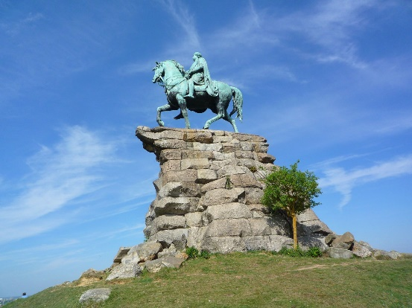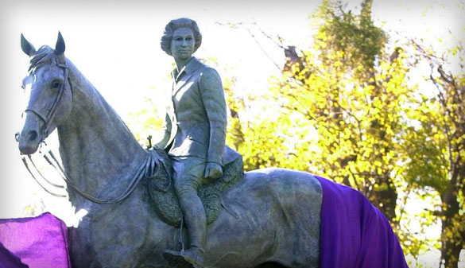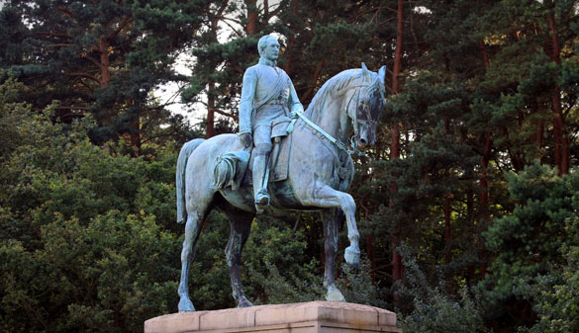
http://www.windsorgreatpark.co.uk/en/heritage/historic-timeline

Who are they? When were they born? How long ago were they born? What did they do? Why is there a statue of them?
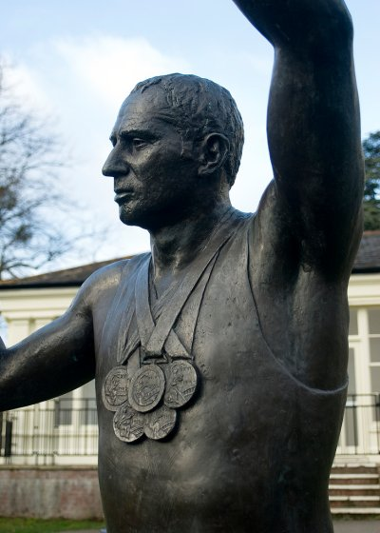 When have they won medals?
Can you create your own timeline and label it with information you have discovered.
WELL DONE to all the parents who helped raise £164.60 at the Robins cake sale before lockdown. I usually ask the children for suggestions of how to spend the money on the classroom. In the past, this has included the trampette and sandpit which are in the outdoor area. Please talk to your child/ren and then email me their ideas before Wednesday 3rd. Thank you!
Keep looking at the school website/class page for updates and please send me examples of what you’ve done. I look forward to hearing from you. Have a good week.

Take care and look after yourselves at this difficult time.
Many thanks for your support,
Mrs Spong robinclass@cheapsideschool.org.uk

