Day 4: Can you fill in what you think the vulture is thinking in each of these pictures?
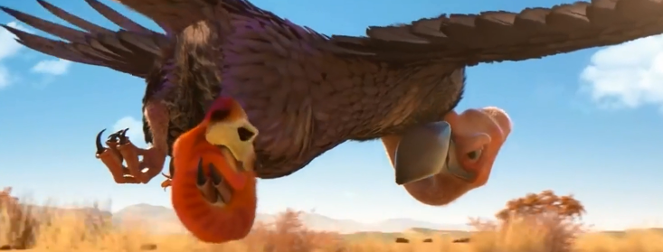

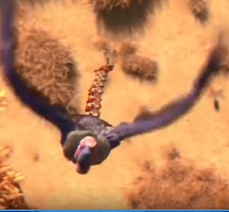

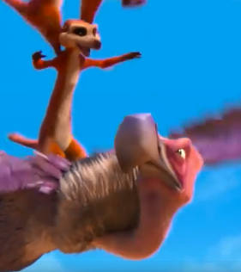

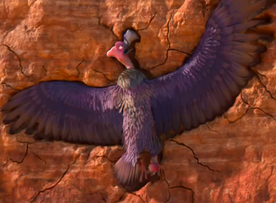

Day 5: Can you create some commentary for the Rugby match at the end of the video? If you like an adult at home could record you giving your commentary.

