
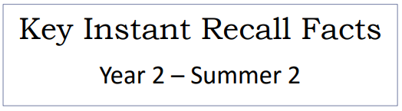

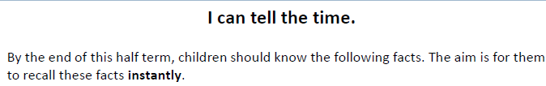

Key Vocabulary
Twelve o’clock
Half past two
Quarter past three
Quarter to nine
Five past one
Twenty- five to ten
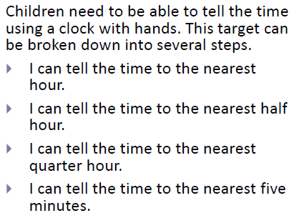
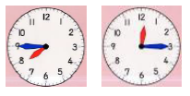

Top Tips
- The secret to success is practising little and often. Use time wisely. Can you practise these KIRFs whilst walking to school or during a car journey? You do not need to practise them all at once: perhaps you could have a fact of the day.
- Talk about time – discuss what time things happen. When does your child wake up? What time do they eat breakfast? Make sure that you have an analogue clock visible in your home or that your child wears a watch with hands.
- Read books about time - many storybooks have opportunities to talk about the seasons and predict the time of year the events take place.
- Ask your child the time regularly – You could also give your child some responsibility for watching the clock:
‘The cake needs to come out of the oven at quarter past four.’
‘We need to leave the house at half past eight.’

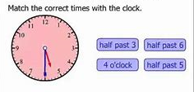
Make it Real!
Ask your child the time!

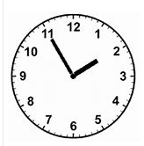
What time is it?
Five to two. How do you know?
Because the big hand is pointing at the eleven and the small hand is at 2.
Absolutely…the small hand tells us about the hour and the big hand tells us how many minutes.

Make it fun!
Sequencing – Give child many different times of the day and ask them to put them in chronological order.
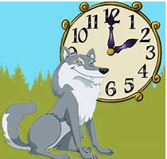
Play What time is it Mr Wolf?

Games and Apps – there are many websites and apps online with access to time telling activities.

Songs and rhymes – there are lots of CDs available with sing long options in order to help children learning to tell the time. 

