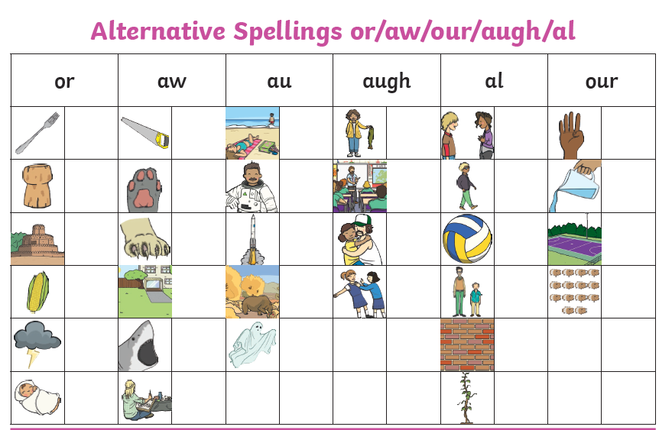

Can you have a go and see how many words you can fill in next to the pictures – the pictures give you a clue!

