Week 3 : English
https://www.youtube.com/watch?v=j6PbonHsqW0
Watch the video a couple of times – it’s very funny , have a go at these activities – there is no pressure to do them all!
If you don’t want to write a whole story then just do a paragraph or even a couple of sentences. Any writing that you do is brilliant practice!
Activity 1. Look at this little picture, as well as watch the video and see if you can answer the questions.
1.What is the man’s job and why is he using a paint brush?
2. What do you think he has found?
3. What happens when he pushes the buttons?
4. What do we call this 3D shape? ( we learnt about it in Maths before Easter?)
5. On which continent would you find Cairo?
6. From watching this video, what can you tell about the weather in Cairo?
7. Did you see the date at the beginning of the film? If it is now 2020, how many years ago did this little adventure occur?
8. Can you find out what we call the big structure that comes out from beneath the pyramid?
9. How does the man get into the pyramid?

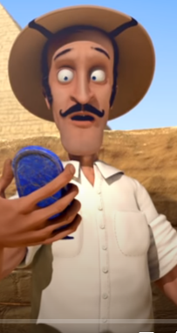

Activity 2: What face do you like the most and why?
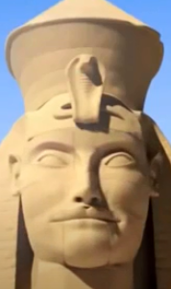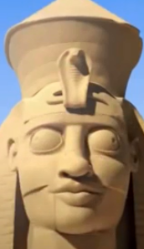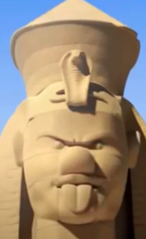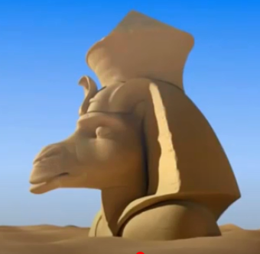
Can you draw a picture of the face you liked best?
Activity 3: Can you write a list of fabulous WOW words to describe what you see in the video (remember wow words are adjectives and describe the nouns )

Activity 4: Draw a picture of what you think the man finds when he disappears into the giant Sphinx?

Activity 5a: See if you can write your name using the Hieroglyphics sheet – maybe someone else’s name in your family too.
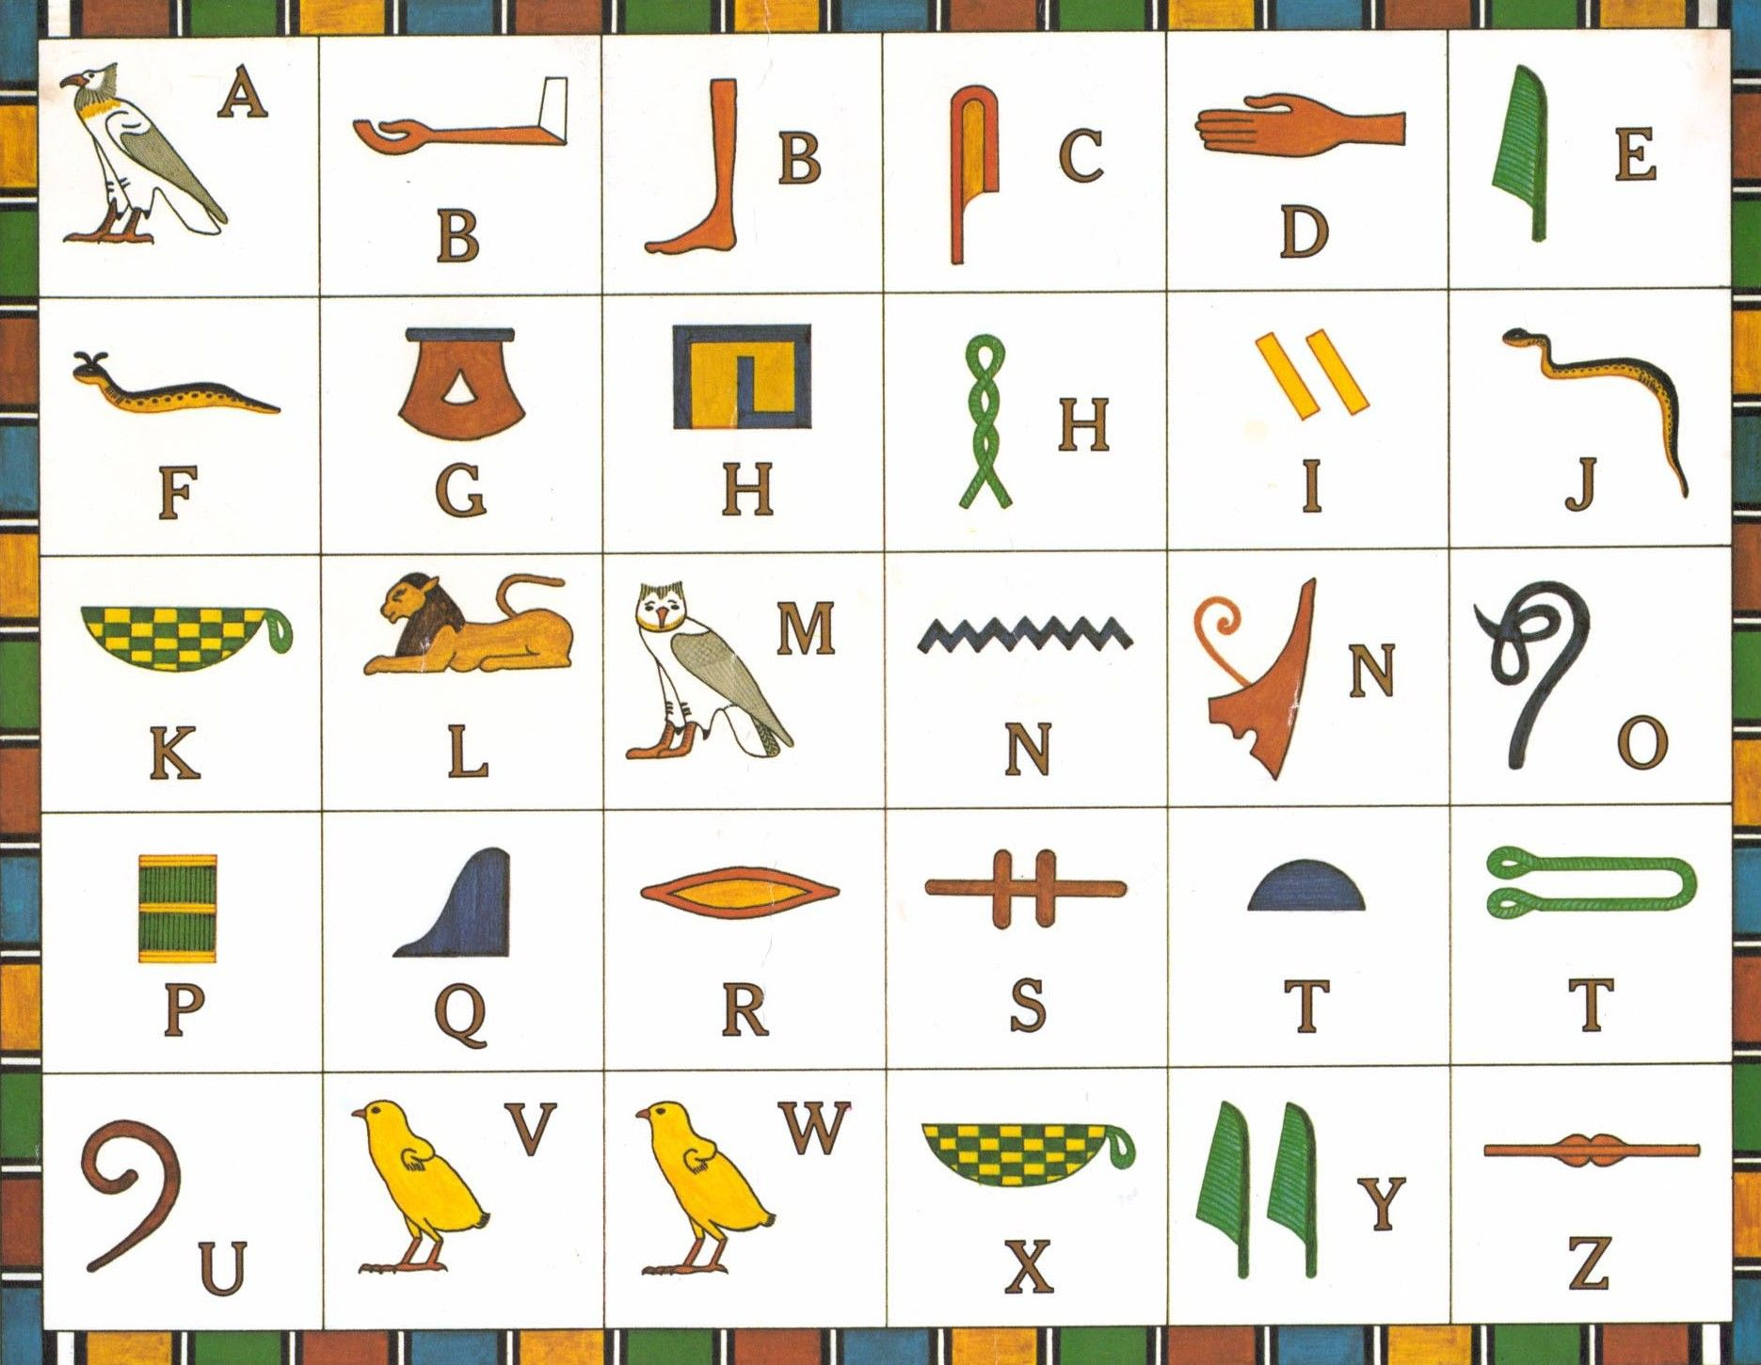
5b: What can you find out about hieroglyphics using either the Internet or books?

