Reading activity – Spend a few days on it.
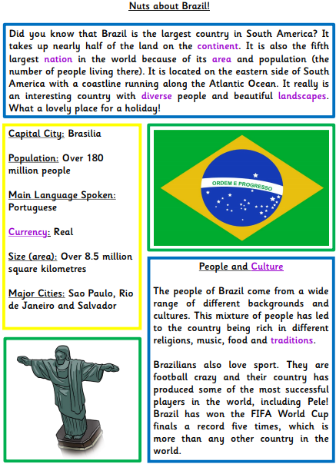
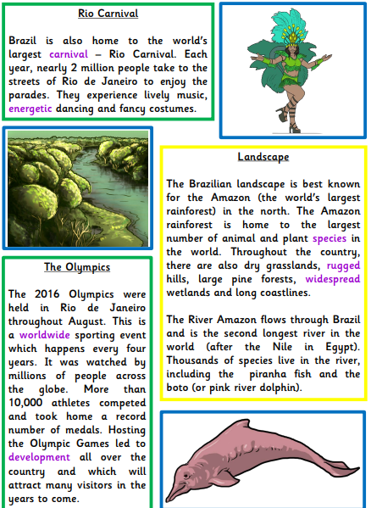

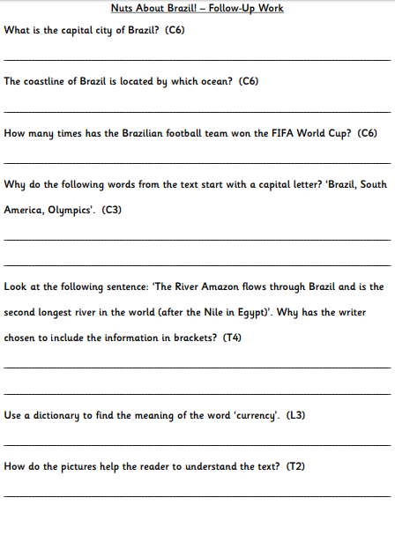

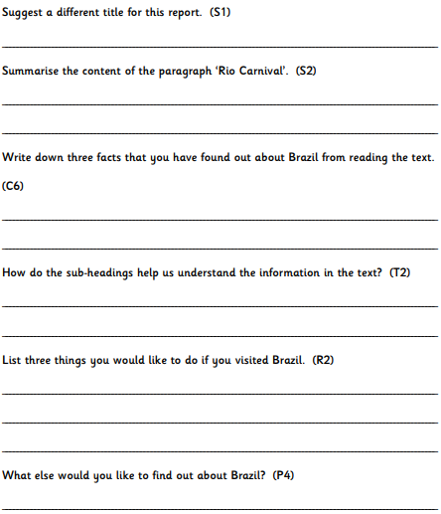

REMEMBER: Sub headings are the little headings in the boxes if information.
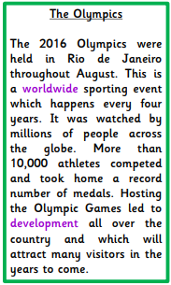
To summarise is to write in your own words a short version of what you think the information is trying to tell you.

