Cheapside Primary School - Geography
Topic: Let’s Explore London |  | Doves Class | Strand: Place Knowledge / Human and Physical Geography
What should I already know? | Words I should be able to spell:  London, palace, tower, Thames, river, underground, trains, tour, square
- The village my school is in is called Cheapside
- Cheapside is in England, which is a country.
- Human (houses, shops, parks, roads) and physical features (river, woodlands) of Cheapside.
London is the capital city of the UK
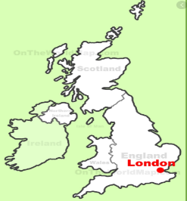
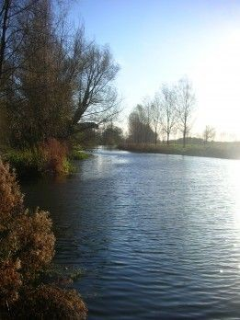
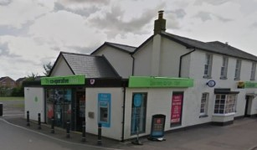
Geographical Skills and Fieldwork
Features of London
 | Human  geographical  features | Physical geographical  features
 | Many houses, shops, offices, apartments  and roads | 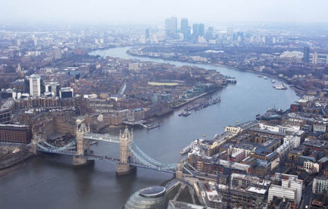  River Thames  Some hills, lakes, forests and parks  Hyde Park  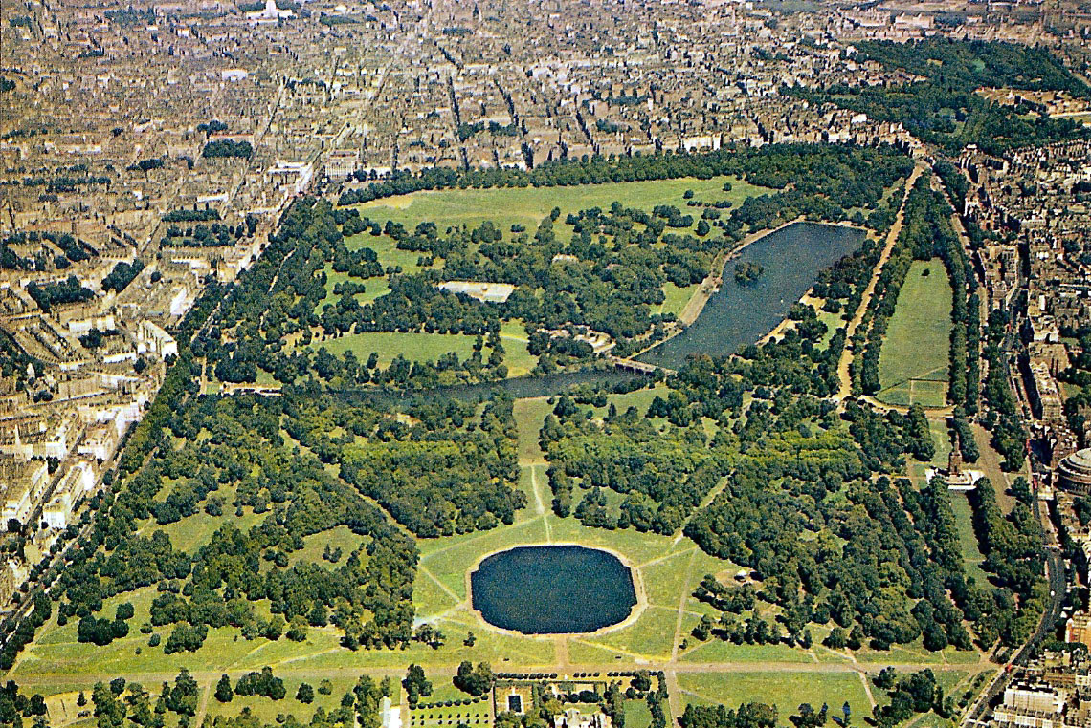
 | 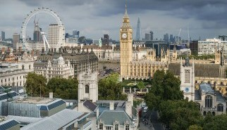
 | Many skyscrapers
 | 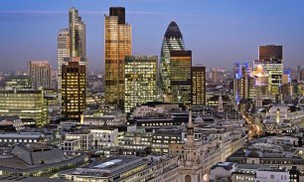
London | Five airports  Over 200 train stations
Famous buildings such as Big Ben, the London Eye, the Houses of
Parliament, Bucking- ham Palace, Tower
Bridge. This means that there are lots of
tourists.
 | Some ports

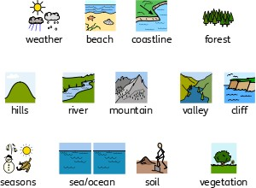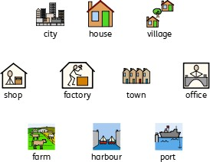
Physical Geographical Features
Human Geographical Features

What else do I need to remember?
There are 4 countries in the United Kingdom, England, Scotland, Wales and Northern Ireland and their capitals are London, Edinburgh, Cardiff and Belfast
Use aerial photographs to study London. What is the same? What is different? Compare to Cheapside
Use a map to find London and Cheapside.
Use a map to find the 4 countries of the United Kingdom and their capitals.
Vocabulary to use and understand
airport | a place where aeroplanes land and take off
capital city | the city where the government sits. London is the  capital city of England and the UK.
city | a large town. London is a city.
forest | a large area where trees grow close together
harbour | a sheltered port so that boats can be left there  safely.
hill | a naturally raised area of land, which is not as high as a mountain.
human features | features of land that have been impacted by human activity
physical features | natural features of land
port | a harbour area where ships load and unload goods or passengers
river | a large, natural stream of fresh water that flows into the sea or a lake.
skyscrapers | a very tall building with many floors
tourist | a person who is visiting a place for pleasure and  interest, especially when they are on holiday.
town | a large group of houses, shops and buildings where people live and work. Towns are larger than  villages but smaller than cities. Sudbury is a town.
train station | a place on a railway line where trains stop for people to get on and off trains.
vegetation | plants, trees and flowers
village | a small group of houses, perhaps with a few shops. Cheapside is a village.

