MATHS – Summer 1 week 1: ( Answers and solutions are in the blue boxes at the end of some of the problem solving questions) Day 1: Fractions: Learning Objectives:1. I can understand the concept of a whole being one object or one quantity. 2. I can make and recognise equal and non-equal parts.
Spend some initially time experimenting with food and/or toys – see if you can separate a piece of fruit into ½ or ¼ or If you have Lego - can you divide some into an equal and an unequal part/amount?
Can you use 2 different colours to divide this page into 2 equal parts in any way you like?

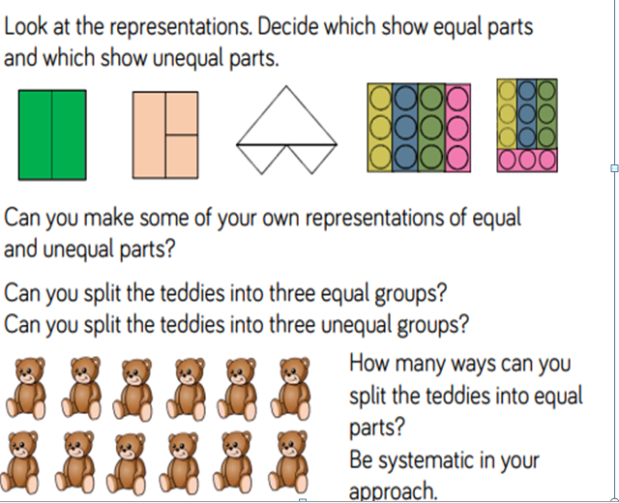
Some Mathematical language to think about and try to use with your child to help their understanding.
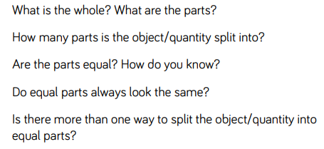

Day 2: Learning Objectives:..
- I can reason and problem solve using what I know about equal parts.
See what your child can remember from yesterday …Get them to tell you what they learnt.

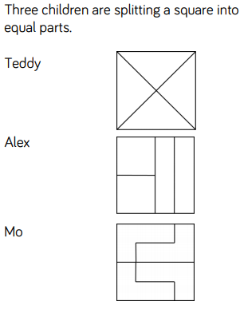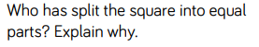
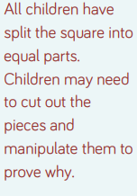
This is the explanation – did your child understand it?

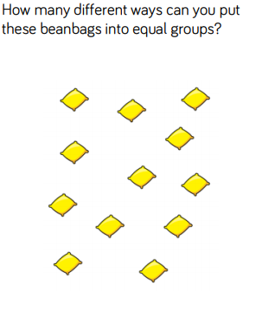
If the children can use objects/fruit/sweets to solve this activity – it would be even better!
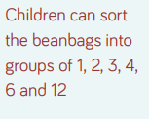
This is the solution did they get it?

Children need to be introduced to the ½ for the first time and they need to understand the meaning of numerator and denominator and what they represent.
Let them explore ‘halves’ in different contexts for example half a length ,shape or set of objects (use an objects you can find at home)

Some Mathematical language to think about and try to use with your child to help their understanding.
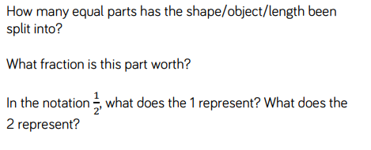
Fraction - A part of a whole. A common fraction is made up of a numerator and a denominator. The numerator is shown on top of a line and is the number of parts of the whole. The denominator is shown below the line and is the number of parts by which the whole has been divided.

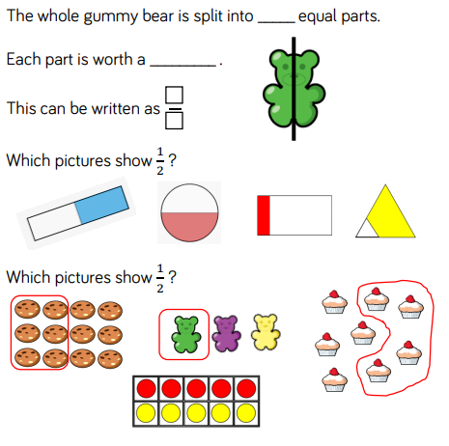
Have a go at this…

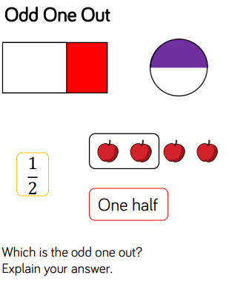
This is the explanation..did your child undstand?
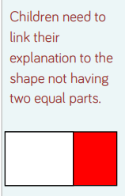

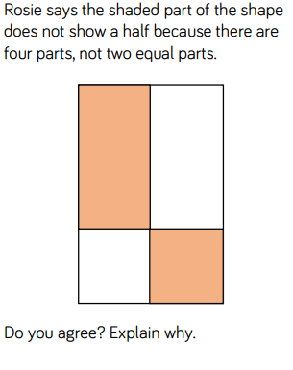
If it helps your child to explain their reasoning let them draw it on a piece of paper

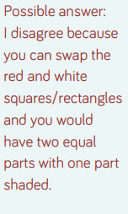

Day 3 Learning Objectives:
- I can recognise and find ½ half.

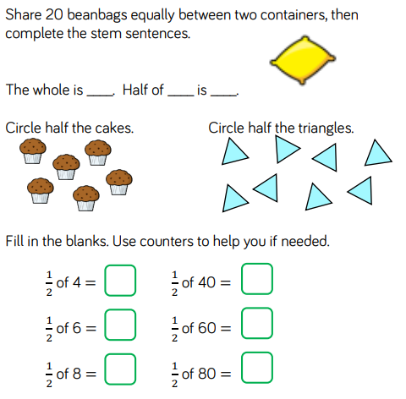
Try to help your child make the link between ½ and dividing by 2
Mathematical language:
TRY USING SOME REAL LFE OBJECTS/SWEETS/TOY CARS ETC AND PRACTICE HALVING THE AMOUNT
How did you halve the sweets?
What is the value of the whole? What is the value of half of the whole? What do you notice?
What do you notice about your answers? How can you use your answer to a half of 4 to help you work out a half of 40?

Day 4: Learning Objectives:
1.I can reason and problem solve by finding a ½

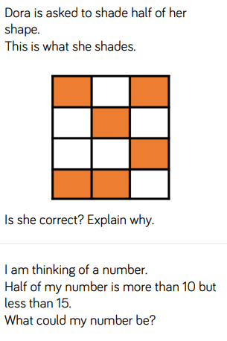
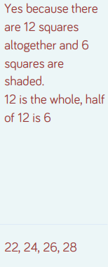
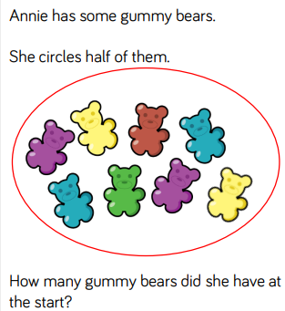
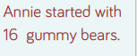

Day 5: Learning Objectives:
1.I can recognise a quarter.
Children extend their knowledge of the whole and halves to recognise quarters of shapes, objects and quantities. They continue to work concretely and pictorially, understanding that they are splitting the whole into 4 equal parts and that each part is one quarter.
Mathematical Language: Cup up a round piece of fruit for your child and help them divide it up into quarters.
How many equal parts have you split the whole into if you have split it into quarters? In 1 4 what does the 1 represent? What does the 4 represent? Can you shade one quarter in different ways? How do you know that you have shaded one quarter? How many quarters make a whole?

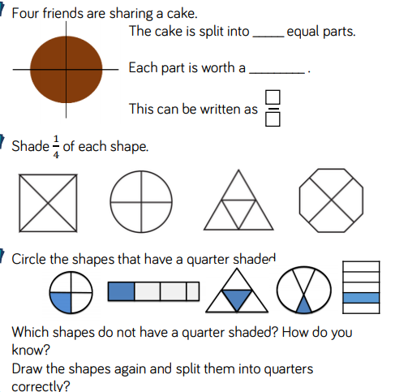

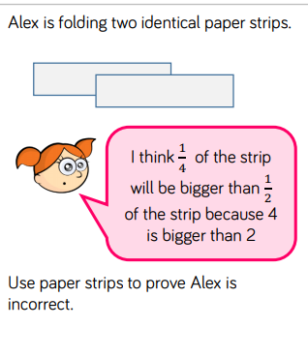
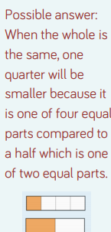

I hope you’ve enjoyed this weeks Maths activities – send me a pic of your work and I’ll put it on the Dove class webpage.x

