English for week 1 – 20-24th April
Monday- Look at the Power point presentation on Brazil.
Can you write down in your English books ( the blue one) 6 sentences about what you have learnt about Brazil from the Power point. Remember to use capital letters, full stops, exclamation marks – if needed and see if you can use some conjunctions in your writing too. Use the Conjunctions word mat to remind yourself of the different conjunctions we could use.
Tuesday – Look again at the Power point on Brazil.
Can you find 6 items in your home that might have come from Brazil?
You can draw pictures of the items you choose or you can take photographs of them.
Write them down in your English book.
Wednesday- There are some unfamiliar words in this Power point see if you can find out what they mean by asking an adult in your home and then write down , in your Blue English book, the word and the meaning.
1.Capital city
2.Currency
3.Independnce
4.Tropical
5.Deforestation
6. Carnival 7. Poverty

Thursday- Have the Power point open in front of you and have a go at answering these questions. Remember to write a full answer using all the punctuation you’ve been taught. Re read your answers when you have finished to make sure they make sense.
- Brazil is named after a tree, do you know which one it is?
- What ocean borders Brazil?
- What is the official language of Brazil?
- We use Pounds and Pence in the U.K , what do they use in Brazil?
- What colours can you see on the flag of Brazil?
- How many stars are on their flag?
- What major river runs through the rainforest of Brazil?
- Can you find and copy 3 important facts about the rainforest?

CHALLENGE QUESTIONS:
- If it’s winter in June in Brazil then what season would it be now in April?
- Do you think everyone lives well in Brazil? Give a reason for your answer.
- Do you think people living in Sao Paolo have a lot of space around them? Give a reason for your answer.
- Can you find out what the word ‘indigenous’ means? You could look it up or ask an adult in your home.

Friday- Have a look at this map and see if you can tell what the different little images might mean?
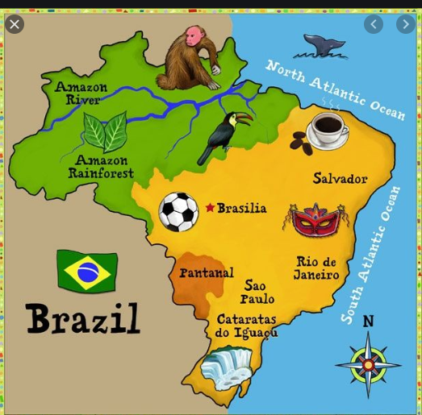

REMEMBER I WILL BE HAPPY IF YOU HAVE A GO AT THIS WEEK’S ENGLISH –DON’T WORRY IF YOU CAN’T DO IT ALL I WILL BE PROUD OF WHAT YOU CAN ACHIEVE.

