


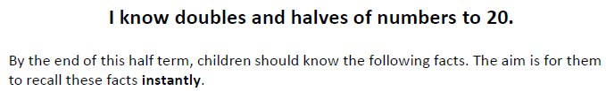

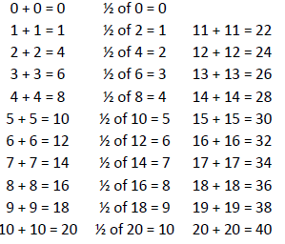
Key Vocabulary
What is double 9?
What is half of 14?
Equal parts
Multiplied by two
Divided by two

Top Tips
- The secret to success is practising little and often. Use time wisely. Can you practise these KIRFs while walking to school or during a car journey? You don’t need to practise them all at once: perhaps you could have a fact family of the day.
- When children are confident with doubles, ask them to find the corresponding halves.
- Practise halving at least as often as doubling. This will help children with subtraction at a later date.

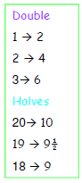
Make it Real!

A cartoon lasts 18 minutes. The next cartoon lasts half as long. How many minutes does the next cartoon last for?
9 minutes! How do you know? Because half of 18 is 9.
If there are 16 shoes. How many dolls can have a pair of shoes?
8 dolls! Can you tell me why? Because double 8 is 16.




Make it Fun!

Ping Pong In this game, the adult says, ‘Ping’ and the child replies, ‘pong’. Then the parent says a number and the child doubles it. For a harder version, the adult can say ‘pong’, the child replies ‘ping’, and then halves the next number given.

Playing Darts Use a magnetic dartboard. Create a game involving doubling and halving.


Dominoes Add together the dots on your domino and then double or half it.

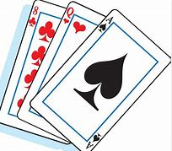 Playing cards Remove the face cards. Choose a card and then either double or half it.

Online games Go to conkermaths.com and see how many you can answer in 90 seconds.

