Maths: Week 3-4-8th May
Please follow the link to access this week’s maths activities. https://whiterosemaths.com/homelearning/year-2/
Once you are on the website please click on week 2, as shown below
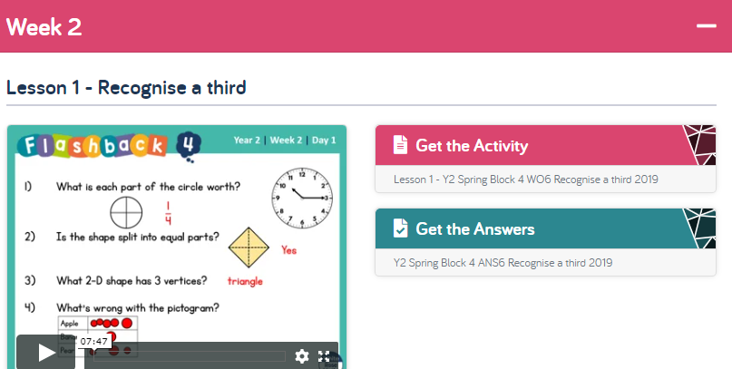
Have a go at the questions after watching the video first and try not to peek at the answers! I’m giving you the links for each day.
Day 1:https://wrm-13b48.kxcdn.com/wp-content/uploads/2020/homelearning/year-2/Lesson-1-Y2-Spring-Block-4-WO6-Recognise-a-third-2019.pdf
Day 2: https://wrm-13b48.kxcdn.com/wp-content/uploads/2020/homelearning/year-2/Lesson-2-Y2-Spring-Block-4-WO7-Find-a-third-2019.pdf
Day 3:https://wrm-13b48.kxcdn.com/wp-content/uploads/2020/homelearning/year-2/Lesson-3-Y2-Spring-Block-4-WO8-Unit-fractions-2019.pdf
Day 4: https://wrm-13b48.kxcdn.com/wp-content/uploads/2020/homelearning/year-2/Lesson-4-Y2-Spring-Block-4-WO9-Non-unit-fractions-2019.pdf
Day 5: https://wrm-13b48.kxcdn.com/wp-content/uploads/2020/homelearning/year-2/Lesson-5-Y2-Spring-Block-4-WO10-Equivalence-of-half-and-two-quarters-2019.pdf

As an extension to the Maths for this week I have also set a couple of NRICH challenges they might like to try – Remember no pressure but your child might enjoy having a go –there is no right or wrong way of approaching these challenges…just enjoy
https://nrich.maths.org/136
https://nrich.maths.org/166&part=

