Activity 1.Writing
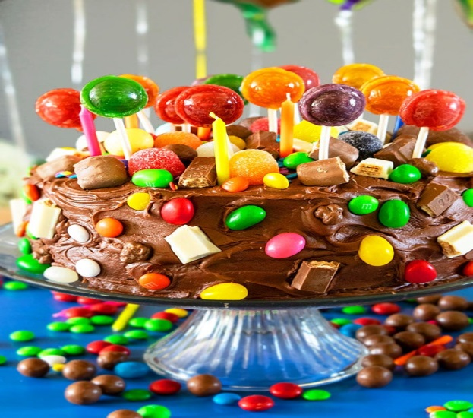
Can you write a real or an invented recipe for a chocolate cake. Can you remember the bossy verbs that we learnt about earlier in Year 2? Here is a quick reminder They are command words: Put, Fetch, Get, Pour, stir, Mix – remember there are no ‘manners’ when writing recipes and instructions!! Plus each new instruction should be numbered and on a new line.

Activity 2. Drawing
My favourite part is... Take a piece of paper and write the words “My favourite part of the Chocolate Cake poem is . . .” Can you draw a picture of your favourite part.

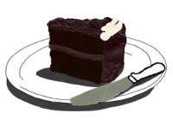

Activity 3. Poem
My favourite food poem: Write a poem about your favourite food You can use the writing frame and word bank below to help you.
My favourite food in the entire world is _____________
It looks_______________________________________
It smells ______________________________________
When I take a bite it makes_________________ sound.

It feels__________________________ in my mouth .
WORD BANK
Shiny delicious gooey yum cold dull sweet bitter soft salty creamy gobble hard
Hot crunchy ahhh

Activity 4: Scrumptious Sentences
Fill in the gaps in the sentences below. You can use the
word bank at the bottom of the page to help you.
1. I had a _________________to eat at playtime.
2. My __________________ stomach loves chocolate
3. Careful not to tread on the ________________ floorboard outside Mum and Dad’s bedroom.
4. I take the knife again and this time ______________________ the crispy icing on the top.
5. You usually ______________________ at the idea of having chocolate cake.

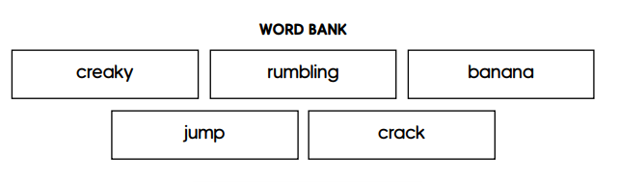
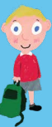

Activity 5: Can you find the adjectives (describing words) and the verbs (doing/action words) and write them in your blue book.
Oh the icing on top
and the icing in the middle
ohhhhhh oooo mmmmmm.
But now
I can’t stop myself
Knife –
I just take any old slice at it
and I’ve got this great big chunk
and I’m cramming it in
what a greedy pig
but it’s so nice,and there’s another
and another and I’m squealing and I’m smacking my lips
and I’m stuffing myself with it
and before I
I’ve eaten the lot.
The whole lot.

Extra Activity: Thinking about what you have been doing in Maths – have a go at this.. 

