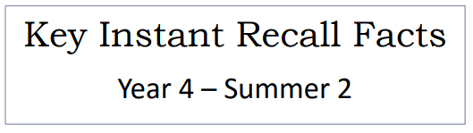


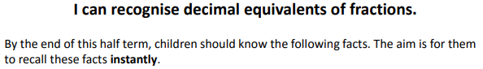

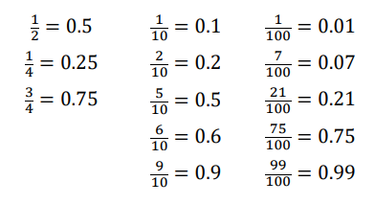
Key Vocabulary
How many tenths is 0.8?
How many hundredths is 0.12?
Write 0.75 as a fraction.
Write ¼ as a decimal.

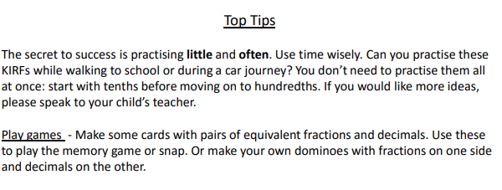

Make it Real!

A piece of ribbon is 1 metre in length. If I cut it and give you 0.5 metres of the ribbon, how would that be represented as a fraction?
1/2! Are you sure? Yes because 0.5 is the same as 50 out of 100, which is equal to ½.


If you were competing in a 100-metre sprint but you had to stop 23 metres in because your shoe fell off, what fraction of the race did you run? Can you give it as a fraction and a decimal?
23/100, which is equal to 0.23! How do you know? Because 23/100 means 23 out of 100.

Make it Fun!
Shout it out! Play ping-pong – one person calls out the fraction and the other replies with the decimal equivalent and vice versa. As an extra challenge: remember to simplify the fraction where you can!
Dominoes – create your own dominoes and then you can play fraction/ decimal dominoes.

Playing cards – create your own playing cards and then you can play snap with fraction/ decimal equivalents.

