


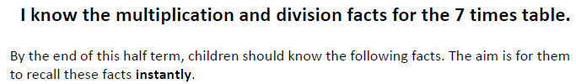
Key Vocabulary
What is 7 multiplied by 6?
What is 11 times 7?
What is the product of 4 and 7?
What is 70 divided by 7?
How many groups of 7 can you make out of 84?
What is the quotient of 56 and 7?
Divisor, dividend, divisible by, multiple ,multiply
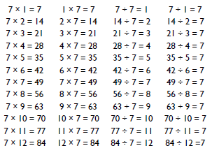
Top Tips
- The secret to success is practising little and often. Use time wisely. Can you practise these KIRFs while walking to school or during a car journey? You don’t need to practise them all at once: perhaps you could have a fact family of the day.
- Look for patterns – these times tables are full of patterns for your child to find. How many can they spot?
- Use Times Tables Rock stars
- Order of difficulty – ask your child to order these facts from the easiest to the most challenging. Can they explain why some facts are easier to remember? Then focus on practising the most challenging facts.
- What do you already know? Your child will already know many of these facts from the 2,3,4,5,6,8 and 10 times tables. It might be worth practising these again!

Make it Real!
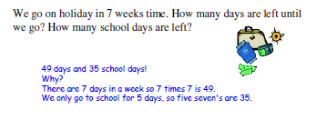

A tent sleeps 7 children. How many tents would you need to sleep 84 children?
12 tents!
Explain why...
84 divided by 7 is 12 and I checked my answer by multiplying 12 by 7.

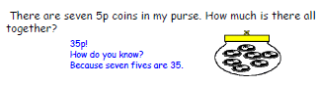

Make it fun!
Make it fun!
Call out! Play ‘Beat the calculator’. One person works out the answer to a multiplication or division question with a calculator and the other person works it out in their head. Who is quicker?
Dice Roll a pair of dice –add the total together and multiply the number by 7. Can you use the inverse to check your answer?
Playing Cards Remove picture cards from the pack. Pick a card and state the multiplication and division fact for the three times table. E.g. pick the ‘7’ card so 7 x 3 = 21, 3 x 7 = 21, 21 ÷ 3 = 7, 27÷ 7 = 3
Dominoes To practise the 7 times table, pick a domino and add together the dots. The child multiplies the total by 7 and then give the associated division fact.
Songs and rhymes There are lots of CDs/ Apps available with musical tables. Great fun to sing along to on long car journeys!
Timed Games How well are you doing? How many questions can you answer in 2 minutes? Can you beat your own record?

