


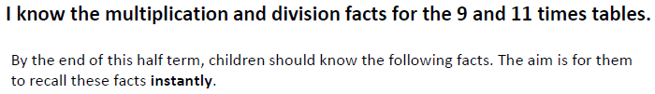

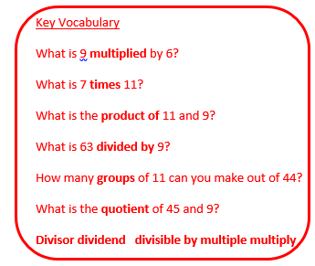
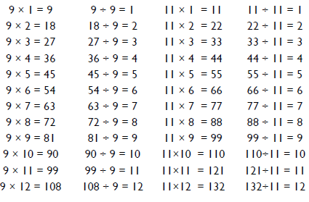

Top Tips
- The secret to success is practising little and often. Use time wisely. Can you practise these KIRFs while walking to school or during a car journey? You don’t need to practise them all at once: perhaps you could have a fact family of the day.
- Look for patterns – these times tables are full of patterns for your child to find. How many can they spot?
- Use Times Tables Rock stars
- Use your ten times table – multiply a number by 10 and subtract the original number (e.g. 7 x 10 – 7 =70 – 7 = 63) What do you notice? What happens if you add your original number instead? (E.g. 7 x 10 + 7 = 70 + 7 = 77).
- What do you already know? Your child will already know many of these facts from the 2, 3, 4,5,6,8 and 10 times tables. It might be worth practising these again!

Make it Real!


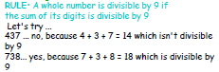
If we make 8 cakes and use 88 grams of sugar, how much sugar would there be in one cake?
11 grams of sugar. How do you know? Because 88 divided by 8 is 11.
We go on holiday in 9 weeks. How many days are left until we go?
63 days!
How have you worked that out?
There are 7 days in a week so 7 x 9 is 63.

Make it fun!
Call out! Play ‘Beat the calculator’. One person works out the answer to a multiplication or division question with a calculator and the other person works it out in their head. Who is quicker?
Dice Roll a dice and generate a two-digit or three-digit number. Discuss whether the number is divisible by 9. How do you know?
Playing Cards Remove picture cards from the pack. Pick a card and state the multiplication and division fact for the three times table. E.g. pick the ‘9’ card so 9 x 3 = 27, 3 x 9 = 27, 27 ÷ 3 = 9, 27÷ 9 = 3
Dominoes To practise the 9 or 11 times table, pick a domino and add together the dots. The child multiplies the total by 9/11 and then give the associated division fact.
Songs and rhymes There are lots of CDs/ Apps available with musical tables. Great fun to sing along to on long car journeys!
Timed Games How well are you doing? How many questions can you answer in 2 minutes? Can you beat your own record?

