


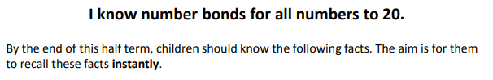

Key Vocabulary
What do I add to 5 to make 19?
What is 17 take away 6?
What is 13 less than 15?
6 plus ? equals 14
How many more than 8 is 11?
What is the difference between 9 and 13?
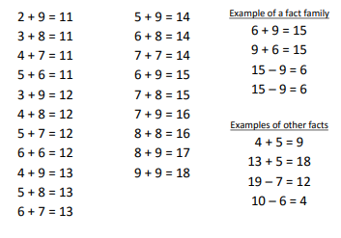

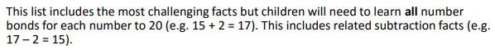
Top Tips
- The secret to success is practising little and often. Use time wisely. Can you practise these KIRFs while walking to school or during a car journey? You don’t need to practise them all at once: perhaps you could have a fact of the day.
- Use practical resources to consider the bonds in a practical way. E.g. Make collections of 20 objects. Ask questions such as, ‘How many more conkers would I need to make 20?’
- Buy one get three free - If your child knows one fact (e.g. 8 + 5 = 13), can they tell you the other three facts in the same fact family? ( 13 - 5 = 8, 5 + 8 = 13, 13 – 8 = 5)
- Use doubles and near doubles – If you know that 6 + 6 = 12, how can you work out 6 + 7?
What about 5 + 7?
- Play games – There are missing number questions at www.conkermaths.com. See how many questions you can answer in just one minute.

Make it real!

There are 17 ladybirds on the leaf. 12 fly away, how many are left?
5 ladybirds!
How do you know?
Well, 12 add 5 make 17.
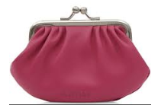
I have 4 pence in my purse. How much more do I need to make 18p?
14p! Why? Because 4 pence and 14 pence is 18 pence altogether.
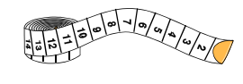

I have 19 cm of ribbon, I cut off 13 centimetres. How much ribbon is left?
6 cm! Why? Because 6 add 13 makes 19.
Make it fun!
Call out!
Play number ping-pong. Start by saying ‘ping’ and the child replies with ‘pong’.
Repeat and then convert to numbers i.e. say ‘2’ and they reply ‘18’ (number bonds to 20).

What’s hidden?
There are 17 beans on this place, I hide some under a cup- how many have I hidden? (bonds for each number to 20.)

Playing cards (take out the picture cards and use joker as zero)
- Play snap by matching the number bonds.
- Play the ‘memory game’ to find matching number bonds.
Dominoes
Connect two dominoes to make the bond. How many more to make 20?
Dice
Roll 2 die to make a bond. How many more to make 20?

Songs and rhymes
E.g. 20 speckled frogs, 20 green bottles, 20 in a bed

Timed games (important that if you do this, the child understands the importance of focusing on the improvement that they are making).
How many questions can you answer in 2 minutes? Can you beat your own record?

