Moving to Year 1

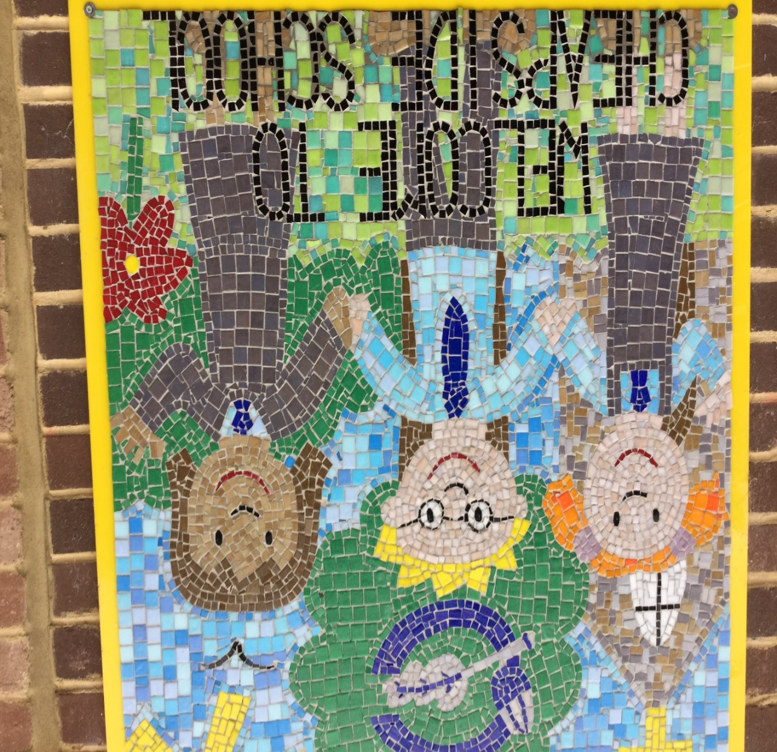

I am going to be in Robins Class.

Dear Robins,
My name is Miss Grigulis and I will be your new class teacher in September.
I have so enjoyed meeting some of you during these last few weeks of term. I really look forward to meeting the rest of you in September. I have heard so many wonderful things about all of you and cannot wait to get to know you all better.
I recently found a picture of myself when I was your age on my first day in year 1 and I remember how excited and nervous I felt starting my new class. I will show you this picture on our first day together. I can’t wait for us all to meet in September and begin learning together.
Wishing you all a happy summer holiday and see you in all in September.
From,
Miss Grigulis

My teacher will help me play and learn.
This is Miss Grigulis, she will be my class teacher.
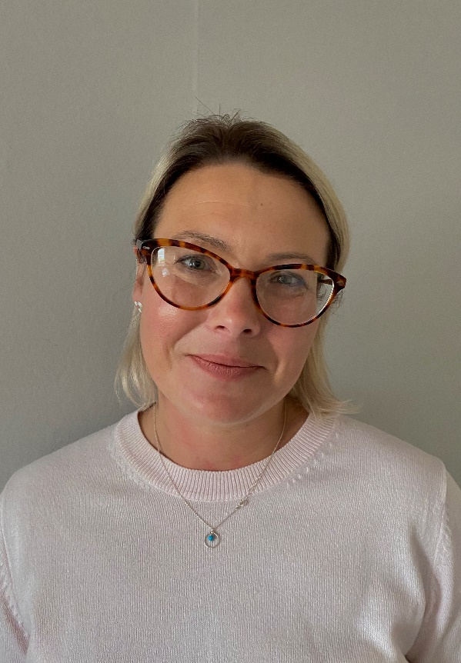

This is my classroom

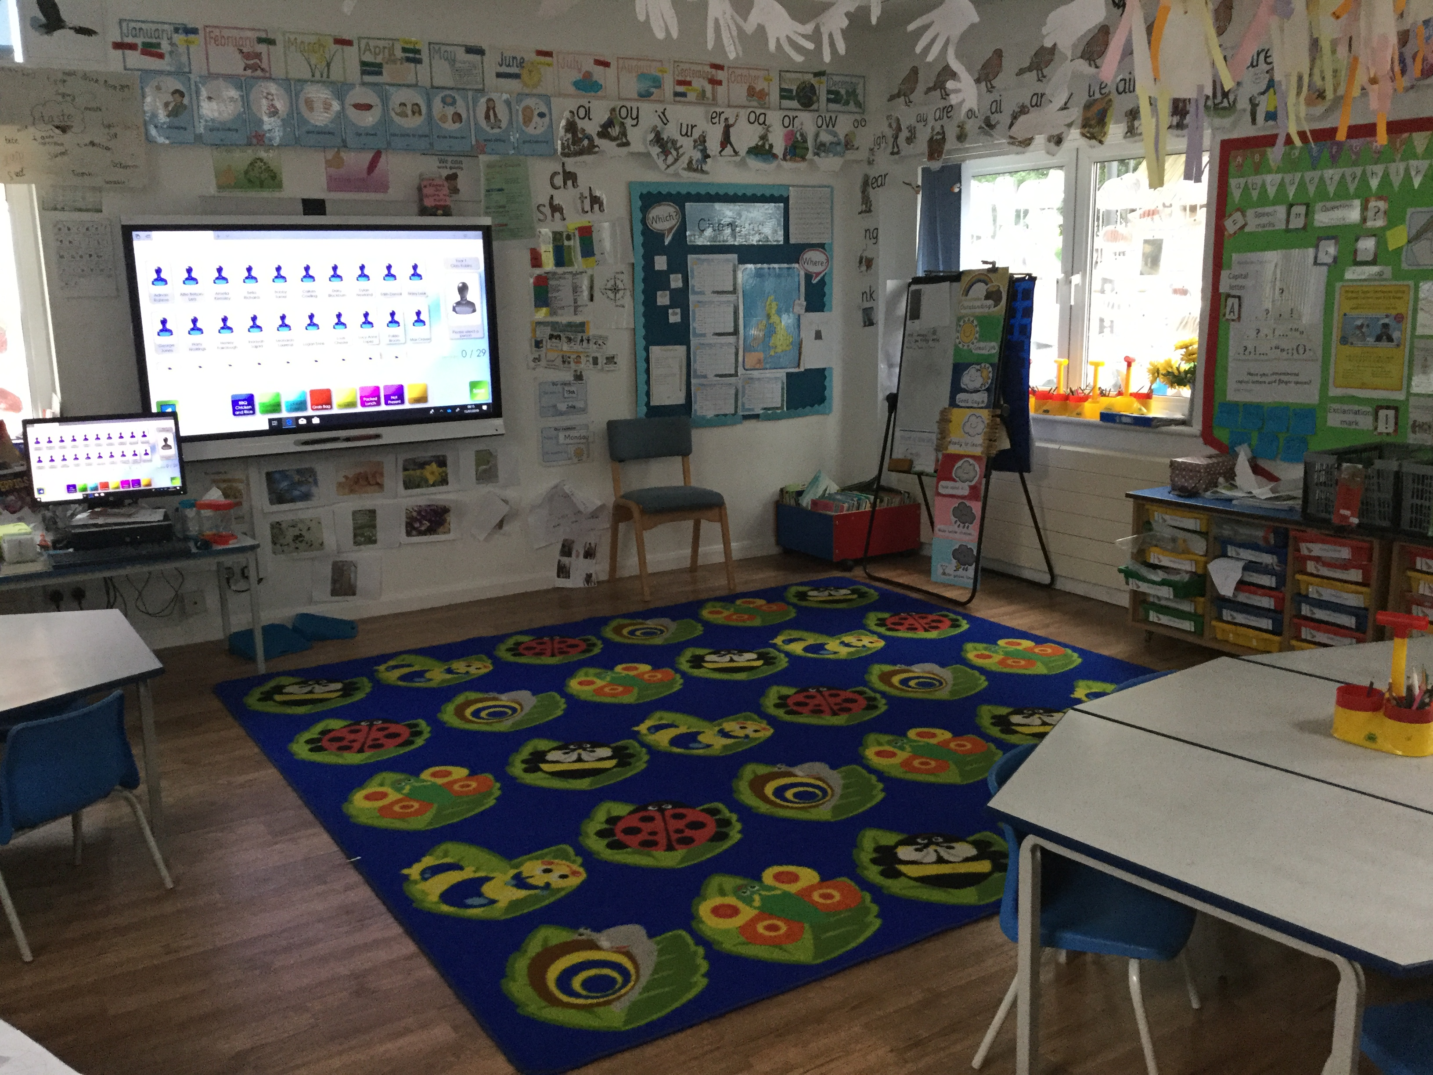

In my classroom I will do my work at the tables.
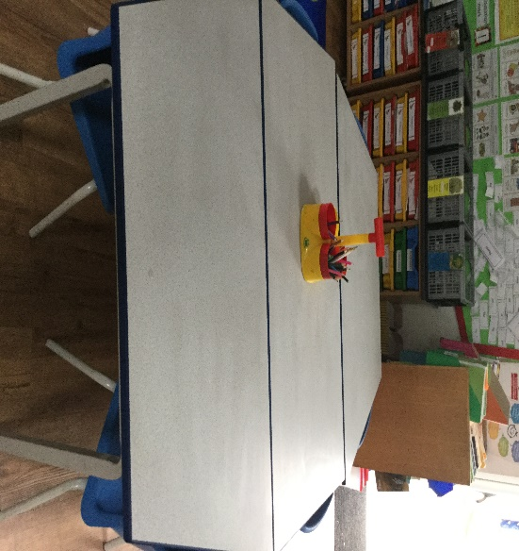

There is also an outdoor area where I can play when I have done my work.

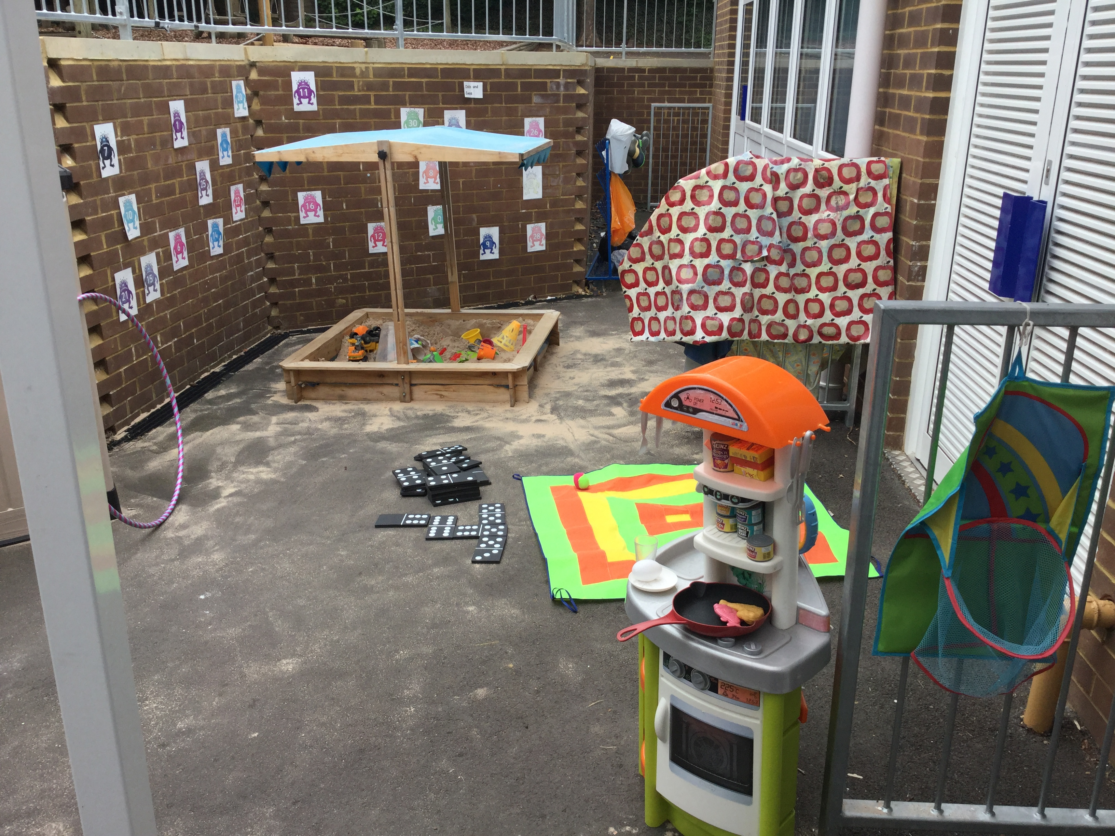

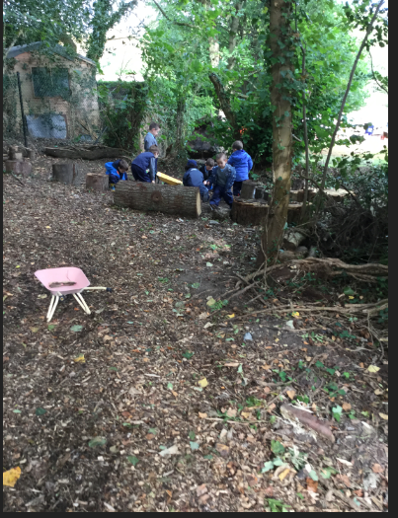
Mrs Miles will still be taking me to Forest School

In my classroom, Mr Ryker will also be helping me to learn and play

I will use the
same toilets.

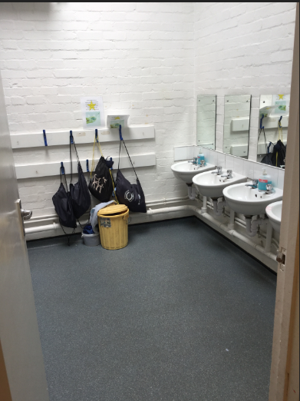

This is where I can hang my coat.
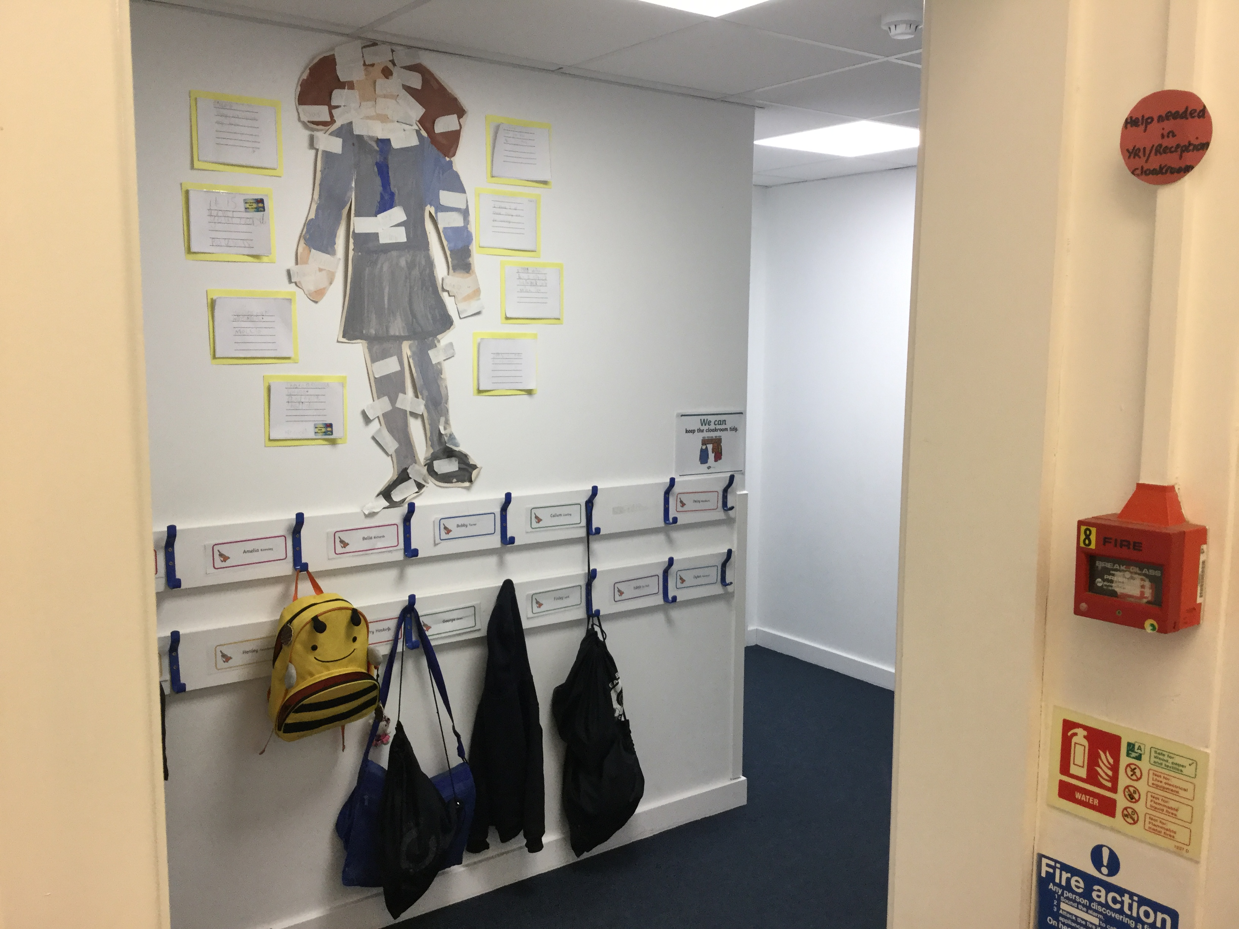
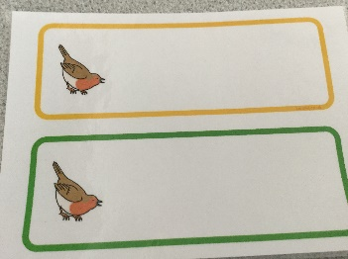 I will have a new peg with my name on it for my coat and PE bag.

I can still use the adventure trail, playground and the field. I can play here at break time and lunch time.
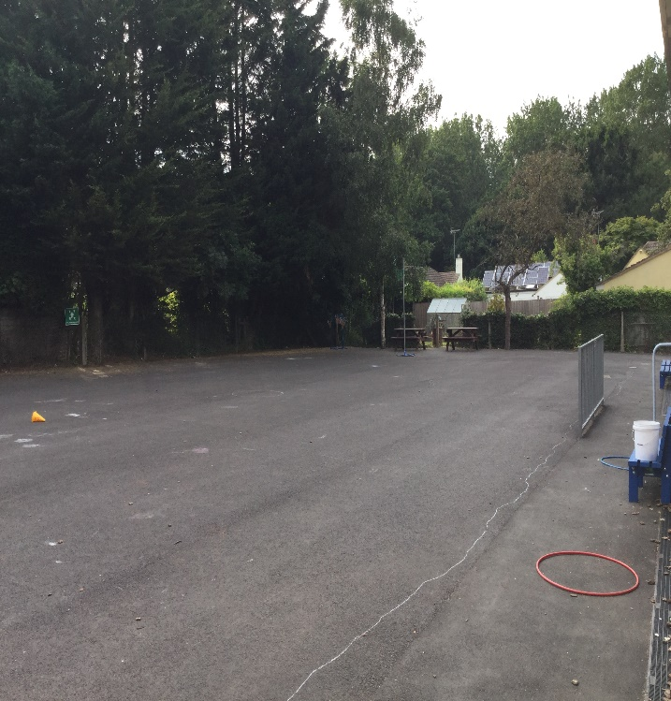
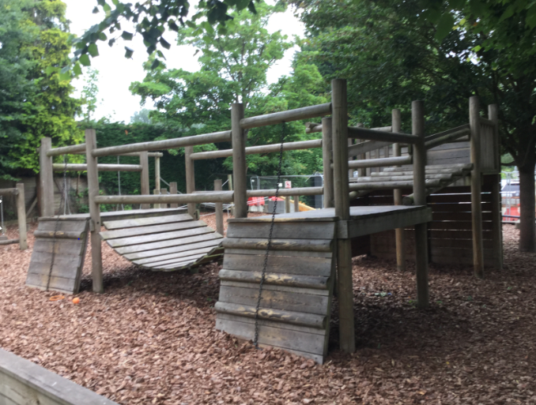

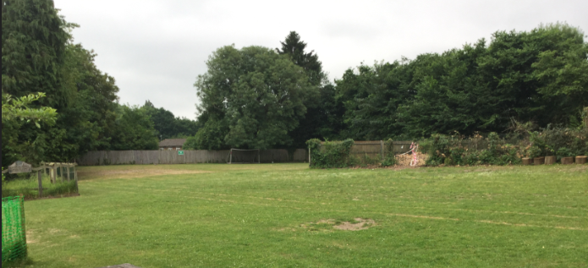

I will still eat my lunch in the hall.
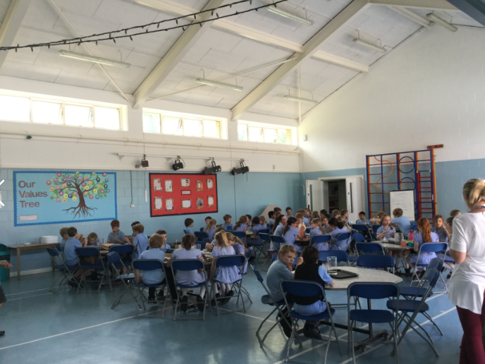

I can choose what I want for lunch each day.

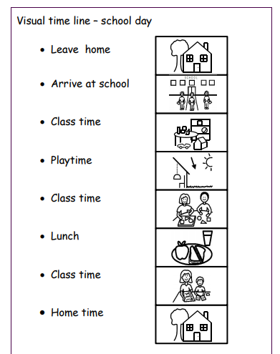
What will happen in a school day?

See you in September!

