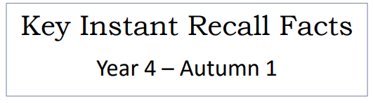


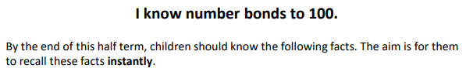

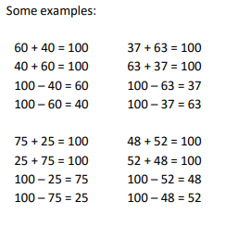
Key Vocabulary
What do I add to 65 to make 100?
What is 100 take away 6?
What is 13 less than 100?
How many more than 91 is 100?
What is the difference between 69 and 100?
What is 100 subtract 36?
Top Tips
- The secret to success is practising little and often. Use time wisely. Can you practise these KIRFs while walking to school or during a car journey? You don’t need to practise them all at once: perhaps you could have a fact of the day. Create regular, short opportunities for rapid fire questions where an instant correct answer is required.
- Use objects to consider the bonds in a practical way.
- Look at the patterns with both objects and numbers e.g. as one number increases the other one decreases
- Practise with the numbers both in order and chosen randomly- remember the aim is to be able to answer immediately.
- Buy one get three free - If your child knows one fact (e.g. 8 + 5 = 13), can they tell you the other three facts in the same fact family? (5 + 8 = 13, 13 – 5 = 8, 13 – 8 = 5)
- Use number bonds to 10 - How can number bonds to 10 help you work out number bonds to 100?
- Play games – There are missing number questions at www.conkermaths.com . See how many questions you can answer in just 90 seconds. There is also a number bond pair game to play.
Make it real!

Jack has £1, he spends 30p. How much change does he get?
70p! Are you sure? Yes, the sum of 70p and 30p is 100p- that is £1.
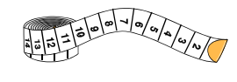

I have 100 cm of ribbon, I cut off 43 centimetres. How much ribbon is left?
57 cm! Why? Because 57 add 43 makes 100.
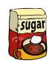
A bag of sugar contains 100g. If I use 34grams how much will I have left?
66 grams! How do you know? The difference between 100 grams and 66 grams is 34 grams.
Make it fun!
Call out!
Play number ping-pong. Start by saying ‘ping’ and the child replies with ‘pong’.
Repeat and then convert to numbers i.e. say ‘2’ and they reply ‘98’ (number bonds to 100).

What’s hidden?
I have 100 beans. There are 46 beans on this plate, how many are hidden under the cup? (number bonds to 100.)

Playing cards (take out the picture cards and use joker as zero)
- Play snap by matching the number bonds.
- Play the ‘memory game’ to find matching number bonds.
Dominoes
Pick a domino from a set facing down. Choose one side to represent the tens digit (e.g. 4 = 40) and the second as the ones. How many more to make 100?
Dice
Roll 2 die, treat the first one as the tens digit (e.g. 6 = sixty) and the second as the ones. How many more to make 100?

Timed games (important that if you do this, the child understands the importance of focusing on the improvement that they are making).
How many questions can you answer in 2 minutes? Can you beat your own record?

