


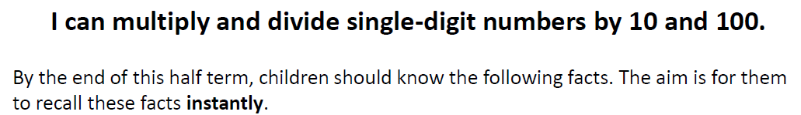`
Key Vocabulary
What is 5 multiplied by 10?
What is 10 times 0.9?
What is 700 divided by 70?
What is the product of 3 and 100?
What is the quotient of 600 and 100?
hundreds, tens, ones, tenths, hundredths
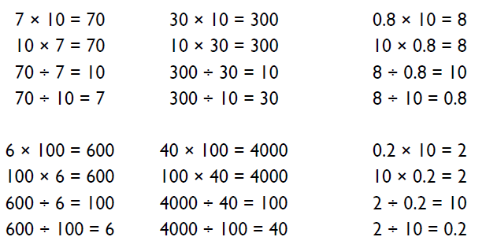

Top Tips
The secret to success is practising little and often. Use time wisely. Can you practise these KIRFs while walking to school or during a car journey? You do not need to practise them all at once: perhaps you could have a fact family of the day.
Buy one get three free - If your child knows one fact (e.g. 10 x 5 = 50) can they tell you the other three facts in the same fact family?
Warning! When creating fact families, children sometimes get confused by the order of the numbers in the division number sentence. It is tempting to say that the biggest number goes first, but it is more helpful to say that the answer to the multiplication goes first, as this will help your child in later years when they study fractions, decimals and algebra.

Make it Real!
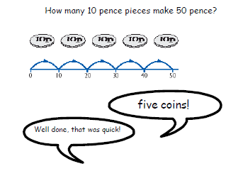
How many pennies are worth the same as 8 pound coins?
800 pennies!
How do you know?
Because there are 100 pennies in £1 and 100 multiplied by 8 is 800.

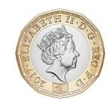

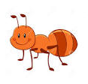
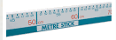
An ant walked 400 centimetres back to its nest. How many metres did it walk?
4 metres! How do you know? Because there are 100 cm in a metre so 400 divided by 100 is 4.

Make it fun!
Dominoes
Pick a domino and add together the spots on the face. Multiply the number by 10 then by 100 – what do you notice? Can you divide the number of spots by 10 and 100?
Playing Cards
Remove the face cards from the pack. Choose a card and multiply/ divide the number by 10 and 100. Are there any connections?
Shout out!
Choose random single digit numbers to multiply or divide by 10 or 100. Who can shout out the answer first?

