


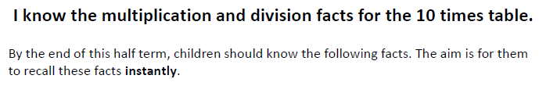

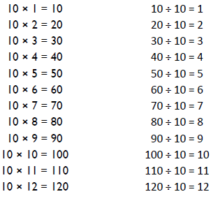
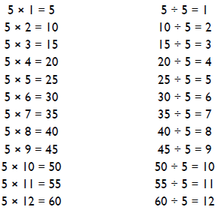

Top Tips
Key Vocabulary
What is 3 multiplied by 10?
What is 7 times 5?
What is the product of 10 and 4?
What is 50 divided by 5?
How many groups of 10 can you make out of 70?
- The secret to success is practising little and often. Use time wisely. Can you practise these KIRFs while walking to school or during a car journey? You don’t need to practise them all at once: perhaps you could have a fact of the day.
- Pronunciation – make sure that your child is pronouncing the numbers correctly and not getting confused between thirteen and thirty.
- Apply facts to real life situations – How many toes are in your house? What other multiplication and division questions can your child make up?

Make It Real!

A recipe for biscuits requires five tablespoons of honey per biscuit. If I make 8 biscuits for a school fete, how many tablespoons will I need?
40 tablespoons!
Why?
5 multiplied by 8 is 40.



Make it fun!
Call out! Play ‘Beat the calculator’. One person works out the answer to a multiplication or division question with a calculator and the other person works it out in their head. Who is quicker?
Dice Roll a dice and generate a two-digit or three-digit number. Discuss whether the number is divisible by 10 or 5. How do you know?
Playing Cards Remove picture cards from the pack. Pick a card, state the multiplication and division fact for the five, and ten times table. E.g. pick the ‘9’ card so 9 x 5 = 45, 5 x 9 = 45, 45 ÷ 5 = 9, 45÷ 9 = 5
Dominoes To practise the 10 times table, pick a domino and add together the dots. The child multiplies the total by 10 and then give the associated division fact.
Songs and rhymes There are lots of CDs/ Apps available with musical tables. Great fun to sing along to on long car journeys!
Test the Parent Your child can make up their own tricky division questions for you e.g. what is 70 divided by 7? They need to be able to multiply to create these questions.
Timed Games How well are you doing? How many questions can you answer in 2 minutes? Can you beat your own record?

