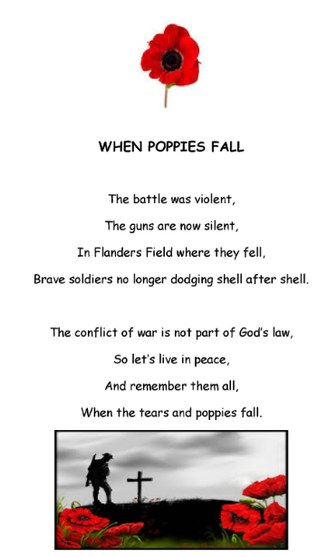
As part of Remembrance day, we would like you to write your own poem, based on World War One.
We have included an example poem for you here. You can use the structure of this poem to write your own. Alternatively, you can write your own poem in any imaginative way you choose.

