
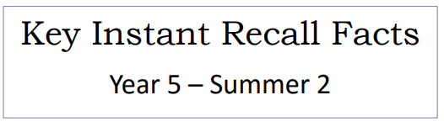



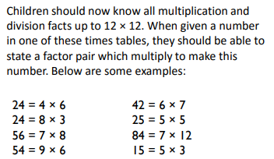
Key Vocabulary
Can you find a factor of 28?
Find two numbers whose product is 20.
I know that 6 is a factor of 72 because 6 multiplied by 12 is equal to 72.
List the common multiples of 3 and 4.


