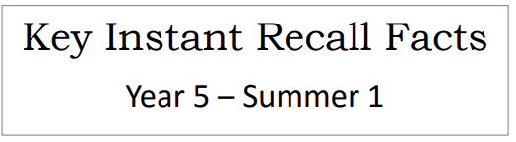


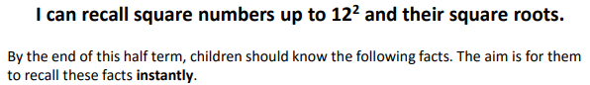

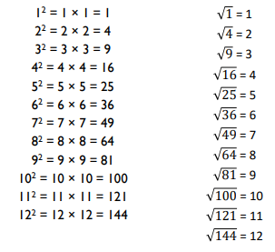
Key Vocabulary
What is 8 squared?
What is 7 multiplied by itself?
What is the square root of 144?
Is 81 a square number?
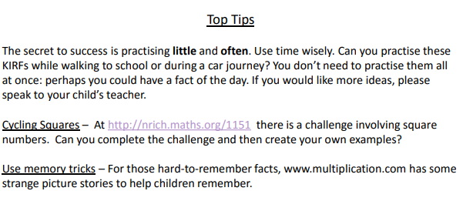

Make it Real!

We go on holiday in 7 weeks. How many days are left until we go?
49 days!
How do you know?
Because there are 7 days in a week and 7$²$is equal to 49 (which is a squared number).

We are going to bake some cakes. We have a square cupcake tin that has rows of 6 cupcake spaces.
How many cupcakes can we bake in the tin?
36 cupcakes! How do you know?
If the tin is a square and one row holds 6 cupcakes then there must be 6 rows altogether and 6 squared is 36.
Our back garden is a square shape and its area is 64metres squared.
How long is one side of the garden?
8 metres! Are you sure?
Yes because 64 is a square number and its square root is 8.
Make it fun!
Call out!
Play ‘Beat the calculator’. One person works out the answer to a multiplication or division question (similar to those above) with a calculator and one person works them out in their head. Who is the quicker?
Dice?
Roll a dice, generate a number and square it.
Dominoes
Add the dots together on the domino before squaring the number. Draw squares to double check your answers.
Timed Games
How well are you doing? How many questions can you answer in two minutes? Can you beat your own record?

