




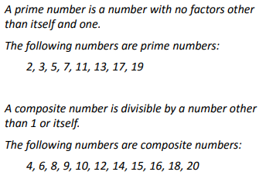
Key Vocabulary
Prime number
Composite number
Divisible by
Factor
Multiples



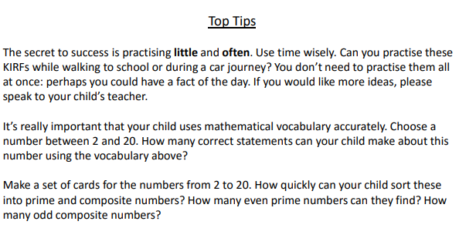

Make it Fun!

- Call out! Play number fizz bang!
Start off by saying ‘fizz’ whilst the child replies with ‘bang’. Repeat and then convert the numbers by counting up in ones from zero to twenty. If the number is a composite, shout ‘fizz’ and if it is a prime number, shout ‘bang’.

- Playing cards

Remove the face cards. Pull a card at random and decide whether it is prime or composite. How do you know? Add two cards together – is the total prime?

- Dominoes
Add together the dots on a domino
Is the total a prime or composite number?

- Timed Games
How well are you doing? How many questions can you answer in 2 minutes? Can you beat your own record?

